A OJT PROJECT REPORT ON
Cost Optimization in Goods Transportation Using Business Analytics – Sairaja Roadways

Submitted to Savitribai Phule Pune University
in Partial Fulfillment of the Requirement for the Award of the Degree of

MASTER OF BUSINESS ADMINISTRATION (MBA)

BY

SAMRUDDHI SAMADHAN RUPNAN

PRN NO. 2052406159

UNDER THE GUIDANCE OF DR. LAKSHMI JASTI

THROUGH


Audyogik Shikshan Mandal’s Institute of Business Management & Research, MBA Institute MIDC, Block ‘C’, Chinchwad, Pune – 411 019.
BATCH 2024-2026

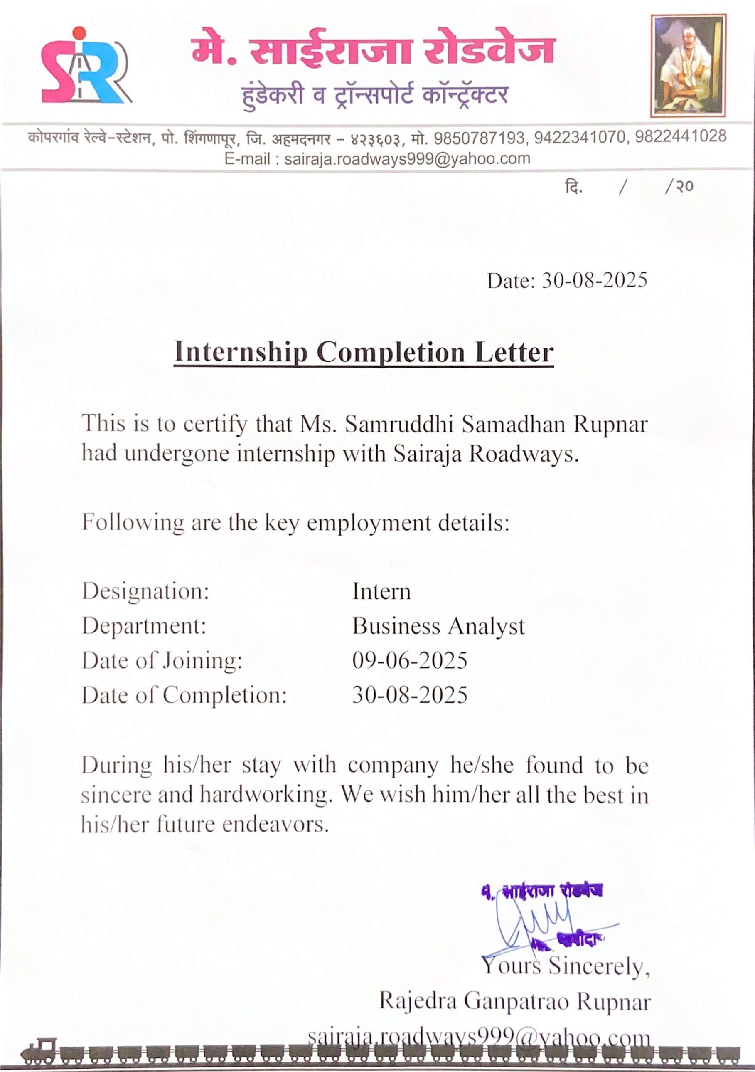
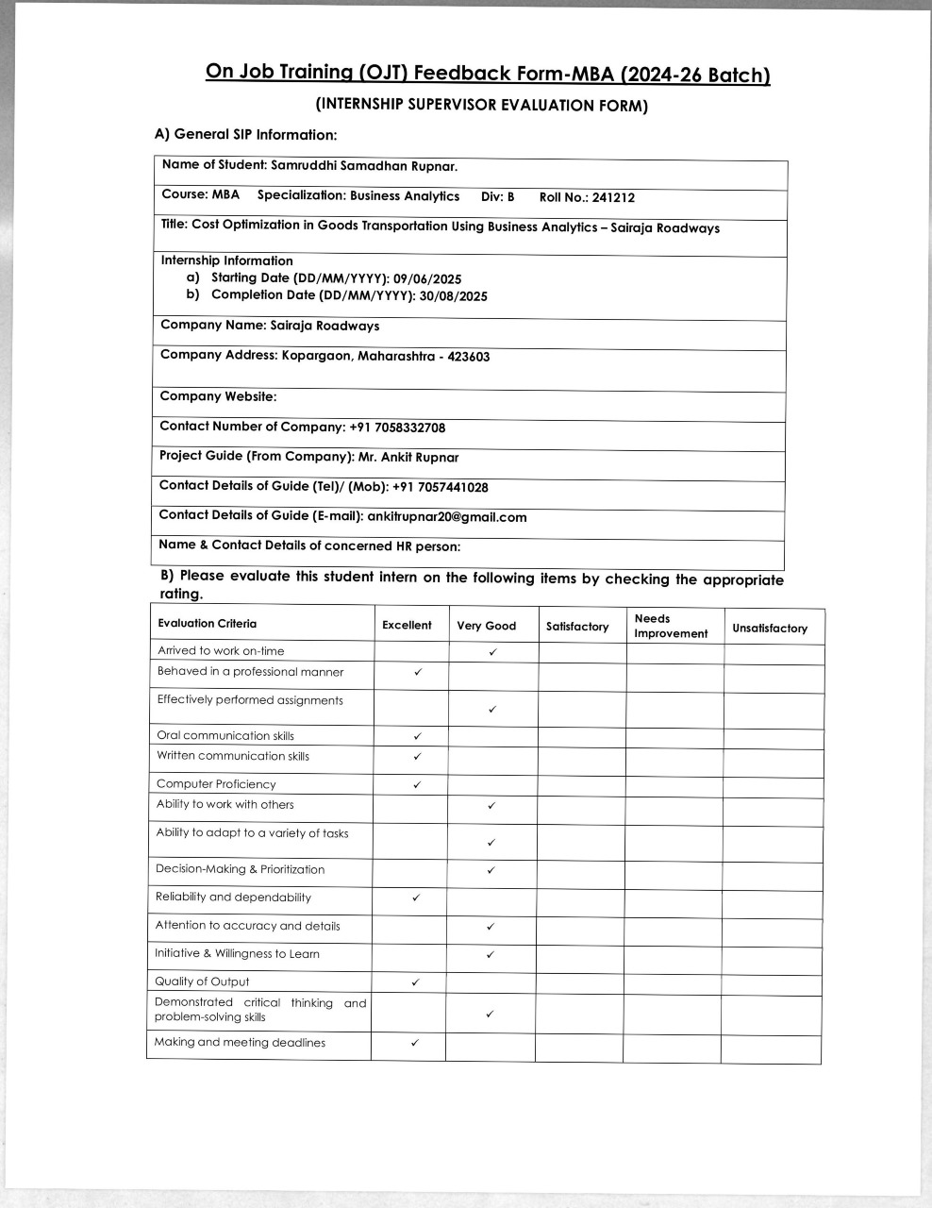

DECLARATION

I, Samruddhi Samadhan Rupnar, a student of MBA (Business Analytics), Semester III, hereby declare that the project report titled: “Cost Optimization in Goods Transportation Using Business Analytics – Sairaja Roadways” is my original work and has been carried out under the guidance of my Faculty Mentor Dr. Lakshmi Jasti and Industry Mentor Mr. Ankit Rupnar (Sairaja Roadways).
I further declare that this report has not been submitted to any other University or Institution for the award of any degree, diploma, or fellowship.
All information and data presented in this report have been collected and utilized sincerely for academic purposes only. Any references to published work, research, or online resources have been duly acknowledged in the reference section of this report.
I take full responsibility for the authenticity and correctness of the work submitted.

Place: Pune

Date:

Signature of the Student
(Samruddhi Samadhan Rupnar)

ACKNOWLEDGEMENT

I take this opportunity to express my sincere gratitude to all those who have supported and guided me during the course of my Summer Internship Project titled “Cost Optimization in Goods Transportation Using Business Analytics – Sairaja Roadways.”
First and foremost, I would like to thank Sairaja Roadways, Kopargaon, for providing me with the opportunity to undertake this project and gain practical exposure to the healthcare software industry. I am especially grateful to my Industry Mentor, Mr. Ankit Rupnar, for their valuable guidance, constant support, and constructive feedback throughout the internship.
I am deeply thankful to my Faculty Mentor, Dr. Lakshmi Jasti, for their continuous encouragement, timely suggestions, and academic guidance which helped me align my project work with the objectives of my MBA curriculum.
I also extend my appreciation to the sales team, business analysts, and staff members of Sairaja Roadways who cooperated with me and provided the necessary data and insights to make this study successful.
This project has been a valuable learning experience, and I am confident that the knowledge and skills gained will help me in my professional journey ahead.

Signature of the Student
(Samruddhi Samadhan Rupnar)

Index

Topic No | Chapter Name | Page No.
I | Title Page | (i)
II | Institution’s Certificate | (ii)
III | Company Certificate | (iii)
IV | Formal Feedback from Industry Mentor | (iv)
V | Declaration by the Student | (vi)
VI | Acknowledgements | (vii)
VII | Index | (viii)
1 | Executive Summary | 1-4
1.1 | Background of the Host Organization | 1
1.2 | Objectives of the Project | 1
1.3 | Methodology Summary | 2
1.4 | Major Learnings and Outcomes | 3
1.5 | Student Contributions | 4
2 | Organization Profile | 5-12
2.1 | History and Current Status | 5
2.2 | Vision, Mission, and Objectives | 5
2.3 | Organizational Structure and Hierarchy | 6
2.4 | Departmental Functions and Student  Role | 8
2.5 | Key Services and Clientele | 8
2.6 | Client Base and Market Share | 9
2.7 | Financial Highlights | 10
2.8 | Industry Overview | 10
2.9 | SWOT Analysis

3 | Outline of the Problem / Task Undertaken | 13-19
3.1 | Introduction to the Topic | 13
3.2 | Problem Statement | 14
3.3 | Rationale Behind the Project | 14
3.4 | Project Objectives, Scope, and Significance | 15
3.5 | Hypotheses | 16
3.6 | Limitations | 17
4 | Research Methodology & Data Analysis | 20-35
4.1 | Research Design | 20
4.2 | Data Collection Methods (Primary and Secondary) | 20
4.3 | Sampling Technique | 21
4.4 | Tools and Software Used | 22
4.5 | Step-by-Step Execution | 23
4.6 | Data Presentation (Tables, Charts, and Graphs) | 23
4.7 | Interpretation of Findings | 30
5 | Data Visualization, Activity Charts and Dashboards | 36-50
5.1 | Introduction | 36
5.2 | Tools Used for Data Visualization | 36
5.3 | Data Overview | 38
5.4 | Visual Representations | 39
5.5 | ServiceNow Dashboard Summaries | 40
5.6 | Summary of Visual Analysis
5.7 | Conclusion

6 | Learning of the Student through the OJT | 51-53
6.1 | Introduction | 51
6.2 | Technical and Analytical Learnings | 51
6.3 | Key Observations and Insights | 51
6.4 | Soft Skills and Professional Learning | 52
6.5 | Overall Learnings | 52
7 | Consideration to Factors such as Environment, Safety, Ethics, Cost, Professional Standards | 54-59
7.1 | Introduction | 54
7.2 | Environmental Considerations | 54
7.3 | Safety Considerations | 55
7.4 | Cost Considerations | 56
7.5 | Technical Learnings | 57
7.6 | Managerial Learnings
8 | Findings, Recommendations and Conclusion | 60-67
8.1 | Introduction | 60
8.2 | Key Findings | 60
8.3 | Recommendations | 63
8.4 | Overall Learnings | 65
8.5 | Conclusion | 66
9 | References | 68-70

1
Executive Summary
---------------------------------------------------------------------------------------------------------

Background of the Host Organization

This project, titled “Cost Optimization in Goods Transportation Using Business Analytics – Sairaja Roadways,” is based on my internship experience at Sairaja Roadways, Kopargaon. The study was carried out from 9th June 2025 to 30th August 2025 under the valuable guidance of Laxmi Ma’am.

Sairaja Roadways is a family-owned transportation company that has been actively involved in the movement of goods and materials across Maharashtra for several years. The organization operates a fleet of approximately 20 trucks, transporting a diverse range of products including FMCG goods, cement, construction materials, agricultural produce and various industrial equipment. With its commitment to timely deliveries and dependable service, Sairaja Roadways has earned a strong reputation for reliability and consistent customer satisfaction. The company primarily operates on routes connecting Kopargaon, Ahilyanagar, Pune, Mumbai, Nashik, and Nagpur ensuring seamless distribution across key commercial regions of the state.

The central objective of this project was to analyze the cost structure associated with the company’s transportation operations and to identify opportunities for reducing operational expenses. To achieve this, the project employed ServiceNow, a business analytics tool used for data management, analysis, and visualization. In the current transportation industry, companies face multiple challenges such as rising fuel prices, increasing toll charges, vehicle maintenance costs, and fluctuating operational demands, all of which have a direct impact on profit margins.

By adopting data-driven analytical methods, businesses like Sairaja Roadways can gain deeper insights into their operations, identify cost-saving opportunities, and make faster, more informed decisions. This project aims to demonstrate how systematic analysis and visualization of transportation data can contribute to overall cost optimization and improved operational efficiency.

Objectives of the Project

To analyse cost structure and monthly operational performance for June, July, and August 2025 using key metrics such as on-time delivery percentage and monthly contribution share.

To identify month-on-month trends in delivery performance and evaluate whether operational efficiency is improving, declining, or remaining stable.

To perform variance analysis by comparing each month’s performance with the overall average to determine deviations and understand the causes behind performance fluctuations.

To use data-driven visual tools such as line charts, bar charts, pie charts, stacked column charts, and area charts to clearly represent performance changes over time.

To assess operational strengths and weaknesses based on actual graphical performance data and identify gaps that require improvement.

To evaluate the contribution of each month to the total operational output and determine which month showed the highest efficiency.

Methodology Summary

The project used a descriptive and analytical methodology to understand the cost structure and operational efficiency of Sairaja Roadways. The study involved primary observations, informal discussions, and secondary data analysis, supported by Microsoft Excel, Google Sheets, and ServiceNow.

1. Primary Data Collection

Primary data was collected through direct workplace observations. This included observing loading, unloading, dispatch planning, fuel filling, and daily vehicle movement. Informal discussions with drivers, the operations team, and accounts staff helped in understanding issues related to fuel usage, toll variations, route conditions, and maintenance needs. This provided practical and real insights into daily logistics operations.

2. Secondary Data Collection

Secondary data was taken from internal company records. This included trip sheets, monthly cost logs, fuel bills, toll receipts, maintenance records, Excel and Google Sheets used by the company, and ServiceNow-generated data tables and reports. Online logistics articles were also referred to for understanding industry practices.

3. Research Design

The study followed a descriptive research design. Quantitative data such as fuel cost, wages, tolls, and maintenance expenses were analyzed using Excel and ServiceNow. Qualitative insights from observations and discussions supported the interpretation of operational challenges and cost patterns.

4. Tools and Software Used

Excel and Google Sheets were used for data cleaning, cost calculations, and creating charts. ServiceNow was used for creating data tables, generating reports, and building dashboards to study monthly operational trends and cost variations. These tools helped in presenting the data in a structured and understandable format.

5. Data Analysis Process

The data was collected, cleaned, and organized. It was then uploaded to ServiceNow for reporting and dashboard creation. Cost analysis and performance metrics were studied using both Excel formulas and ServiceNow analytics. Insights were verified through staff discussions and validated using secondary research.

6. Data Presentation

The findings were presented through bar charts, pie charts, and ServiceNow dashboards showing the monthly operational summary, cost analysis, and performance metrics. These visual tools helped in clearly identifying cost drivers and operational inefficiencies.

Major Learnings and Outcomes
Throughout the duration of this project, I gained valuable insights into how Business Analytics can be effectively applied in real-world business environments to enhance decision-making and reduce operational costs. Working with live transportation data at Sairaja Roadways gave me a practical understanding of how analytical tools support cost optimization and operational improvement.
Using Microsoft Excel and ServiceNow, I was able to collect, organize, visualize, and interpret data related to the company’s day-to-day transportation activities. These tools played a crucial role in transforming raw operational data into actionable insights that guided better decision-making.

Key Learnings:

1. Practical use of Microsoft Excel
I learned to use Excel for accurate data entry, cost tracking, preparing dashboards, and creating visual charts that represent month-wise operational trends. This improved my ability to organize, analyze, and present transportation data effectively.

2. Application of ServiceNow for analytics and reporting
Through ServiceNow I was able to organize logistics data more systematically. The tool allowed me to generate visual reports, automate data handling, and interpret cost-related patterns such as fuel usage, toll expenses, and maintenance tracking. It also helped in clearly visualizing performance metrics for operational decision-making.

3. Understanding data-driven decision-making
The project strengthened my understanding of how analyzing cost components—fuel, maintenance, wages, and tolls—supports better decisions. These insights help identify inefficiencies, reduce operational expenses, and improve resource allocation.

4. Exposure to real-time logistics operations
I observed route planning, vehicle scheduling, fleet monitoring, cargo handling, and driver management processes. This exposure enabled me to connect theoretical concepts with the practical challenges of transport operations.

5. Development of technical and analytical skills
By working with Excel and ServiceNow, I enhanced my analytical thinking, problem-solving abilities, data interpretation skills, and professional communication—skills essential for operations and logistics roles.

Outcomes of the Study

1. Fuel consumption emerged as the highest cost component

Graphical analysis showed that fuel accounted for nearly half of the total transportation cost, making it the major contributor to operational expenditure.

2. Noticeable reduction in monthly operational costs

Operational expenses decreased from ₹9.2 lakhs in June to ₹8.1 lakhs in August 2025. This reflects improved route planning, efficient vehicle use, and better cost monitoring practices.

3. Improvement in delivery efficiency

On-time delivery performance increased from 84% in June to 91% in August, indicating that monitoring operational metrics helped enhance delivery reliability and overall efficiency.

4. Demonstrated the value of analytics for small businesses

The study showed that even a small transport company can use simple analytical tools like Excel and ServiceNow to reduce costs, improve performance, and support better decision-making.

Student Contributions

- Collected and organized monthly operational data
I gathered data for June, July, and August 2025, including on-time delivery percentage, average delivery time, and monthly operational outputs, to support objective 1 (monthly performance analysis).

- Performed month-to-month comparison of operational metrics
I compared the performance of all three months to identify trends, improvements, or declines in delivery efficiency, directly contributing to

- Conducted variance analysis using Excel
I calculated deviations from the overall average for each month (delivery efficiency, cost components, and time performance)

- Created visual charts and dashboards in Excel
I prepared bar charts, pie charts, line charts, stacked column charts, and comparison graphs to clearly present changes in operational performance over time.

- Analyzed strengths and weaknesses based on graphical data
I assessed patterns such as reduction in operational costs, fluctuations in delivery efficiency, and high fuel dependency to identify operational gaps.

- Evaluated monthly contribution to total performance
I analyzed which month contributed the most to operational efficiency, cost savings, and delivery reliability.

- Used ServiceNow to access and verify performance data
I worked with ServiceNow dashboards to cross-check cost-related data (fuel, toll, maintenance) and ensure accuracy before chart creation and analysis.

- Prepared insights and summaries based on data analysis
I interpreted the results of each graph and contributed meaningful insights for the outcomes of the Study section.

2
Organization Profile
---------------------------------------------------------------------------------------------------------

History and Current Status

Sairaja Roadways is a logistics and transportation company based in Kopargaon, Maharashtra. Founded in 2010 by a visionary local entrepreneur, the company began with humble beginnings—a small rented office and just two trucks operating on a few local routes. Recognizing the rising demand for reliable goods transportation, the founder gradually expanded the business, investing in new vehicles, improving services, and strengthening customer relationships.

Over the years, Sairaja Roadways has grown into a respected small-to-medium-sized enterprise with a fleet of around 20 trucks. The company’s primary routes include Kopargaon–Pune, Kopargaon–Mumbai, Ahilyanagar, Nashik, and Nagpur, ensuring reach to major commercial and industrial hubs across Maharashtra. The business has built a solid reputation for delivering goods safely and punctually, earning the trust of local factories, agricultural producers, wholesalers, and traders.

The company specializes in handling a diverse range of goods, including FMCG products, agricultural produce, industrial materials, and construction supplies. This mixed-goods model allows Sairaja Roadways to efficiently utilize capacity and serve a broad spectrum of clients. Its role is crucial in the regional supply chain, connecting production sites, warehouses, and markets, thereby facilitating the smooth movement of goods.

Today, Sairaja Roadways is managed by the founder’s family, maintaining a strong focus on customer satisfaction, operational transparency, and cost efficiency. Though still a growing company, it has embraced basic digital tools to streamline operations. Excel-based systems are used for trip scheduling, fuel monitoring, load tracking, and vehicle maintenance logs.
This semi-automated approach ensures the business can monitor key performance indicators and plan preventive actions.

Despite resource constraints, the management continually seeks ways to adopt better practices and integrate technology, with an aim to reduce operational costs and improve delivery service. This makes Sairaja Roadways a compelling example of a traditional logistics company adapting to modern business environments.

Vision, Mission, and Core Philosophy:

Vision:
To be recognized as a leading logistics solution provider that seamlessly connects various industries with their markets through safe, efficient, and cost-effective transportation services. Sairaja Roadways aspires to adopt modern logistics practices and become a benchmark for reliability and innovation in the regional transport sector.

Mission:
Sairaja Roadways is dedicated to provide timely, transparent, and high-quality logistics services, ensuring that every consignment is delivered with utmost safety and care. The company aims to foster customer trust and loyalty through continuous improvement, operational excellence, and a customer-first approach. Its mission is also to empower its workforce, embrace the latest technologies, and contribute meaningfully to India’s trade and supply chain landscape.

Core Philosophy:
The core philosophy of Sairaja Roadways is to deliver reliable, safe, and timely transportation services while maintaining transparency and trust with customers. The company believes in continuous improvement, cost efficiency, and strong commitment to operational excellence.

Organizational Structure and Hierarchy

1. Owner / Proprietor

Heads the entire organization and takes all major business decisions.

Oversees transport operations, client relationships, and financial planning.

Provides instructions and final approvals for trips, costing, and logistics activities.

2. Supervisor / Operations Coordinator

Manages the daily transportation operations of the company.

Plans routes, assigns trips to drivers, and monitors vehicle movement.

Acts as the communication link between the owner, drivers, and customers.

Ensures timely delivery and resolves operational issues.

3. Accountant / Accounts Assistant

Handles all financial record-keeping for the business.

Manages fuel expenses, toll records, maintenance bills, and driver wage calculations.

Prepares monthly cost summaries used for operational analysis (matching the project objectives).

Supports data required for Excel-based performance comparisons.

4. Drivers / Transport Staff

Carry out goods delivery and operate vehicles on assigned routes.

Report trip details, fuel usage, and delivery timings.

Play a key role in achieving monthly on-time delivery performance (directly linked to your project analysis).

5. Helpers / Loading Staff (if applicable)

Assist drivers in loading and unloading goods.

Support smooth and timely execution of transportation tasks.

Departmental Functions and Student Role

Sairaja Roadways is a medium-scale transport enterprise with simple yet effective departmental coordination. The following departments directly support the operational performance analysis carried out in this project.

Operations Department

The Operations Department forms the backbone of daily logistics functions.
Key Responsibilities:

Trip Assignment: Allocating available trucks to clients based on destination and load.

Route Planning: Selecting efficient routes to reduce distance, travel time, and fuel consumption.

Performance Monitoring: Tracking delivery progress and ensuring timely arrival.

Load Management: Coordinating with clients to maximize vehicle load and reduce partial-load trips.

2. Accounts Department\

This department ensures financial control and tracks cost-related data used for analysis in this project.
Key Responsibilities:

Trip Cost Tracking: Recording fuel usage, tolls, maintenance, and driver allowances.

Billing & Invoicing: Preparing accurate client invoices.

Payment Management: Monitoring pending and cleared payments.

Cost Insights: Providing monthly expense summaries used for variance and trend analysis.

Maintenance Department

Responsible for keeping vehicles in good running condition to avoid delays and breakdowns.
Key Responsibilities:

Routine Servicing: Oil changes, brake checks, engine maintenance.

Breakdown Coordination: Quickly resolving on-road issues.

Health Logs: Maintaining vehicle maintenance records.

Spare Parts Control: Managing essential consumables.

4. Administration Department

Ensures smooth communication and documentation support.
Key Responsibilities:

Driver Scheduling: Maintaining duty rosters.

Client Coordination: Handling queries, loading details, and delivery updates.

Documentation: Managing permits, insurance, trip sheets, and compliance files.

HR Support: Maintaining attendance and basic administrative tasks.

During the OJT period, my contribution involved:

Collecting month-wise performance data (June–August 2025).

Preparing Excel-based charts (bar, pie, line, stacked column) for trend and variance analysis.

Cross-checking operational data through ServiceNow.

Identifying strengths, weaknesses, and monthly contribution patterns based on graphical insights.

Supporting operational analysis through cost tracking and delivery performance evaluation.

Key Services and Clientele

Sairaja Roadways offers essential transportation services supporting various industries in Maharashtra. These services directly contribute to operational data used in the performance analysis.

1. Full Truckload (FTL) Transportation

For customers requiring entire truck capacity.

Ideal for industrial shipments and bulk goods.

2. Part-Load (LTL) Transportation

Cost-sharing model for smaller shipments.

Efficient for small businesses with irregular dispatch patterns.

3. Industrial & Agricultural Goods Transport

Regular movement of:

Machinery, equipment, raw materials

Agricultural produce like sugarcane, onions, cereals

FMCG products, construction materials

4. Short-Term & Long-Term Logistics Contracts

Seasonal contracts

Manufacturing dispatch cycles

Dedicated vehicle services

5. On-Demand Delivery Services

Urgent or last-minute deliveries within Maharashtra.

Supports fast-moving and time-sensitive consignments.

Client Base and Market Share

Sairaja Roadways serves a wide range of customers across Maharashtra, contributing to consistent month-wise operational data.

Key Client Segments:

Local Industries (Kopargaon, Shirdi)

Regular transport of raw materials and finished goods.

FMCG Distributors (Pune, Mumbai)

High-frequency dispatches requiring on-time performance.

Construction & Hardware Suppliers (Nashik)

Heavy materials like cement, steel, sand, tiles.

Agricultural Sector (Ahilyanagar District)

Transport of grains, onions, sugarcane, and perishables.

Market Strengths:

Timely delivery

Flexible capacity

Transparent costing

Strong regional understanding

These strengths directly influence monthly delivery efficiency and operational performance.

Sairaja Roadways has developed a diversified client portfolio comprising small and medium-sized businesses across different sectors. Operating primarily in Maharashtra, the company provides reliable goods transportation services tailored to meet industry-specific needs. Its consistent service quality and client-focused approach have earned it a reputable position in the regional logistics landscape.

Key Client Segments:
    - Local Industries (Kopargaon & Shirdi Region):
- Manufactures, processing units, sugar factories, and small-scale production houses.
- Regular transportation of raw materials and finished goods.
- Provides trip-based and contract-based services aligned with production cycles.

FMCG Distributors and Wholesalers (Pune & Mumbai):
- Handles stable supply chains for household and retail goods.
- Supports rapid replenishment of stocks in urban retail centers.
- Timely delivery is crucial in this sector, ensuring product availability in competitive markets.

Construction and Cement Suppliers (Nashik):
- Provides logistics support to hardware suppliers, construction contractors, and cement dealers.
- Transports bulky materials like cement bags, steel rods, tiles, and sand.
- Plays an essential role in supporting infrastructure growth in the region.

Agricultural Transporters (Ahilyanagar District):
- Works closely with farmers, mandis, and cold-storage units.
- Transports farm produce like grains, onions, sugarcane, and perishables.
- Flexible loading and dispatch scheduling helps maintain freshness and market alignment.

Market Position and Strengths:
Sairaja Roadways has steadily built its market share by offering:
- Timely Deliveries: Minimizing transit delay through planned routing and vehicle

readiness.
- Transparent Billing Practices: Clear cost breakdowns that build trust and ease client relationships.
- Flexible Capacity: Ability to serve both bulk and part-load orders, fulfilling varied customer needs.
- Regional Expertise: Deep understanding of road conditions, seasonal traffic, and local regulations in Maharashtra.
The company continues to expand its client base by delivering value-added services and nurturing long-term relationships. Its growing role within the supply chain ecosystem positions it as a reliable partner for small and medium scale industries across western Maharashtra.

Financial Highlights
Although specific financial figures remain confidential, a basic understanding of the cost structure and revenue model provides valuable insights into Sairaja Roadways’ financial performance and areas for cost optimization. The company operates on a trip-based revenue model, where income is generated based on the distance traveled, load capacity utilized, and type of goods transported.

Revenue Model:
- Revenue per trip is determined by:
  - Distance of the route (e.g., Kopargaon–Mumbai trips earn more than short local trips).
  - Type and volume of goods (bulk agricultural goods vs. FMCG or machinery).
  - Client type (contract-based clients receive negotiated rates, while on-demand services are billed at market or premium rates).
- The company also offers certain value-added services such as express deliveries or multi-point loads, which may generate additional income.

Major Cost Components:
- Fuel Costs – ~50%
  - Fuel is the highest variable cost due to frequent long-distance trips.
  - Consumption depends on vehicle condition, road quality, and idle time.

  - Fluctuating fuel prices significantly impact overall operational efficiency.

Tolls and Maintenance – ~20%
  - Includes highway tolls, state taxes, and vehicle maintenance (lubrication, parts replacement, etc.).
  - Routine servicing reduces breakdowns and enhances fuel efficiency.
  - Tolls often vary based on the route and need to be considered in trip planning.

Driver Wages and Allowances – ~15%
  - Fixed wages plus trip-based allowances for food, rest, and overnight stays.
  - Bonus incentives are provided for safe and on-time deliveries.
  - Maintaining driver morale and safety indirectly reduces operational risks.

Miscellaneous Expenses – ~15%
  - Includes loading / unloading charges, parking fees, penalties, and emergency expenses.
  - Administrative costs such as office utilities, communication, and documentation also fall under this category.

Profit Margins:
- Margins vary based on factors such as:
  - Route efficiency: Efficient routing minimizes fuel use and time delays, boosting profitability.
  - Fuel rates: Sudden hikes in fuel prices or lack of fuel-control measures can erode margins quickly.
  - Truck utilization: Full or near-full capacity trips generate higher profit per kilometer than partial loads.
  - Maintenance practices: Preventive maintenance reduces costly breakdowns, impacting both operational uptime and budget.

Industry Overview

    - India's road transport industry is an essential backbone of the logistics sector, accounting for nearly 60% of the country’s freight movement. The sector supports a range of industries including manufacturing, agriculture, retail, and construction by

enabling the seamless flow of goods across regions. With a vast network of national and state highways, India’s transport operations are reaching even the most remote locations.

    - However, the industry faces several challenges such as fluctuating fuel prices, rising toll costs, regulatory taxes like GST, and competition from large logistics players. Fuel costs alone represent around 40–50% of operating expenses, making efficient fuel utilization critical for profitability. As a result, companies are adopting digital solutions like route optimization, real-time tracking, and online invoicing tools such as ServiceNow to gain better visibility, lower wastage, and enhance decision-making.

    - The industry is also affected by seasonality. Demand rises during harvest seasons and festive periods, resulting in increased revenue opportunities. However, high demand also increases pressure on logistics providers to improve fleet utilization and minimize breakdowns.

    - With the government investing in infrastructure projects like the Bharatmala and Sagarmala programs, the road logistics sector is expected to grow steadily. Small and medium-scale companies like Sairaja Roadways are especially adapting to these changes by modernizing their operations, improving financial planning, and offering tailored services to meet the evolving needs of clients in the competitive logistics landscape.

SWOT Analysis
A SWOT analysis enables Sairaja Roadways to understand its internal capabilities and external business environment. It assesses Strengths, Weaknesses, Opportunities, and Threats, helping to plan strategic improvements.

Strengths
- Established Reputation: Sairaja Roadways has built a strong brand image over the years by consistently delivering goods on time, earning trust among local industries.
- Long-Term Customer Relationships: Strong customer retention has ensured stable and recurring business, especially within the FMCG, agriculture, and construction sectors.
- Fleet Ownership: The ownership of 20 well-maintained trucks (10–20 tons) allows the firm to have direct control over delivery timelines and service quality, reducing dependency on outsourced vehicles.
- Quick Decision-Making: Being a family-owned and managed business helps the company maintain operational flexibility and respond swiftly to market changes or customer demands.
- Experienced Drivers: The company’s fleet is managed by skilled and reliable drivers with excellent route knowledge, which enhances service reliability and safety.

Weaknesses
- Manual Data Handling: Critical data like fuel consumption, trip expenses, and delivery records are maintained manually, leading to delays and errors.
- Lack of Digital Integration: No dedicated use of systems like ServiceNow, GPS, or mobile apps results in inefficient tracking and coordination of operations.
- Limited Modernization of Assets: An aging fleet increases maintenance costs and decreases fuel efficiency, affecting margins.
- Weak Online Presence: The company lacks a website or digital marketing strategy, limiting its exposure to potential clients outside its local network.
- Inconsistent Cost Monitoring: Absence of consistent cost tracking mechanisms leads to delays in identifying inefficiencies or losses, impacting profit management.

Opportunities
- Technology Adoption: Incorporating modern tools like ServiceNow, Excel dashboards, or GPS tracking can provide better data control, faster reporting, and improved decision-making.
- Market Expansion: There is a strong scope to expand operations to nearby states or new industries like pharma, e-commerce logistics, or specialized cold chain deliveries.
- Growth in E-commerce and FMCG Sectors: With rising demand in these sectors, more businesses require reliable goods movement services, providing opportunities for higher trip volumes.
- Government Support: Schemes like Bharatmala and logistics parks offer improved road infrastructure, reducing travel time and operational difficulties.
- Customization Services: The company can offer value-added services like real-time tracking, digital proof of delivery, and contract logistics solutions to differentiate itself.

Threats
- Fuel Price Volatility: Regular hikes in fuel prices drastically affect transportation costs and profitability.
- Competitive Landscape: Larger transport players with advanced systems and bigger fleets may offer cheaper services and steal market share.

- Regulatory Challenges: Frequent policy changes regarding permits, GST, sanctions, vehicle age or emission standards may increase compliance costs.
- Poor Road Infrastructure: Bad roads and unexpected breakdowns can delay deliveries, affect customer satisfaction and increase expenses.
- Economic Uncertainty: Recessions, pandemics, or shifts in market demand can reduce trip frequency, impacting revenue stability.

3
Outline of the Problem / Task Undertaken
---------------------------------------------------------------------------------------------------------

Introduction to the Topic
The transportation sector is a crucial pillar of India’s logistics network, facilitating the movement of raw materials and finished goods across states. With nearly 60% of freight movement in India being carried out through road transport, this industry plays a significant role in supporting both regional and national economies. However, the sector faces numerous challenges, primarily due to fluctuating fuel prices, increasing toll charges, unpredictable maintenance costs, and irregular trip patterns.
Sairaja Roadways is a medium-sized transport firm based in Kopargaon, Maharashtra, owned and operated by a local entrepreneurial family. With a fleet of approximately 20 trucks, the company provides transport services for a wide range of goods, including construction materials, fast-moving consumer goods (FMCG), agricultural produce, and industrial components, across major cities like Ahilyanagar, Pune, Mumbai, Nashik, Chh Sambhajinagar and Nagpur.
Despite being operational for over a decade and enjoying long-term client relationships, Sairaja Roadways is grappling with rising operational costs. The major challenges include:
- Irregular fuel consumption and rising fuel expenses
- Unscheduled vehicle breakdowns leading to high maintenance costs
- Lack of route optimization resulting in inefficient use of time and resources
- Manual expense record-keeping that limits detailed cost analysis
- Lack of a systematic process for monitoring driver performance and trip metrics
Given these issues, the company lacks visibility into key performance indicators (KPIs) related to efficiency, profitability, and cost management. To remain competitive in the market, it is essential to transition from intuitive decision-making to data-driven management.
This project aims to analyze operational and cost-related data using Microsoft Excel and ServiceNow analytics tools. By extracting and visualizing data related to fuel consumption, trip routes, distances, and maintenance, the objective is to identify:
- Patterns in cost overruns
- Opportunities for fuel and route optimization

- Solutions to reduce operational inefficiencies
- Key areas where digital tools can support better decision-making
Ultimately, this business analytics-based approach is intended to enhance cost tracking, minimize wastage, and improve overall operational efficiency at Sairaja Roadways. This will support the organization’s efforts to sustain profitability in an increasingly competitive logistics market.

Problem Statement
During the course of the internship at Sairaja Roadways, a critical issue identified was the lack of systematic cost monitoring and data-driven decision-making in transportation operations. Although the company records trip details like fuel consumption, toll charges, and maintenance costs, these records are either maintained manually or entered into basic Excel sheets without proper categorization or analysis.
This unstructured approach to data management leads to several challenges:
- Lack of insight into route-wise profitability: The company is unable to determine which routes or clients contribute more revenue versus those that incur higher costs.
- No visibility into fleet performance: Without vehicle-wise analysis, inefficiencies like poor mileage, frequent repairs, or underutilization of specific trucks remain unnoticed.
- Fuel and maintenance expenses go unchecked: Rising fuel prices make cost control essential, yet the company does not track fuel consumption trends or compare fuel usage across trips.
- Delayed and inconsistent reporting: Manual reporting delays prevent timely analysis, affecting future cost estimates and operational planning.
- Absence of visual tools: Without charts, dashboards, or real-time reports, it becomes difficult for management to understand cost structures or identify patterns that require immediate action.
In summary, the absence of a systematic and analytical approach to operational cost tracking directly affects profitability and hampers the company's ability to respond to changing business conditions. Incorporating business analytics tools could enable better monitoring, real-time insights, and data-backed decision- making, which are crucial for controlling costs and improving efficiency in the logistics sector.

Rationale Behind the Project

The transportation and logistics industry operates on thin profit margins due to the dominance of recurring operational expenses such as fuel, toll charges, vehicle maintenance, and driver wages. These costs, when not monitored and optimized, can significantly erode margins, especially for small and medium-sized transporters like Sairaja Roadways. In such a highly competitive environment, even small savings on each trip can lead to substantial improvements in overall profitability when accumulated across multiple trips and vehicles.
Traditionally, Sairaja Roadways has relied on manual accounting and basic record-keeping practices, which limit its ability to perform detailed analysis of operational expenses. This not only restricts financial visibility but also prevents effective decision-making related to route optimization, costing, and resource utilization.
This study was undertaken with the following key aims:
- To analyze the distribution of operational costs across major categories such as fuel, tolls, repairs, and maintenance, and to understand their relative impact on total trip costs.
- To utilize simple yet powerful analytical tools like Microsoft Excel and ServiceNow to structure and visualize trip-wise and vehicle-wise cost data, making it easier for management to interpret trends and patterns.
- To provide actionable recommendations for reducing avoidable expenses (such as fuel wastage or inefficient routes) and for improving overall efficiency in the logistics process.
The broader significance of the study lies in demonstrating that data-driven analysis tools are not exclusive to large logistics companies. With the right approach, smaller transport businesses can also leverage basic analytics to gain financial clarity, increase operational transparency, and improve their strategic planning. This project thus serves as a model for how small to medium-scale transporters can adopt business analytics to drive growth and profitability in an evolving industry.

Project Objectives, Scope and Significance Objectives of the Study
The project aims to address the cost management challenges faced by Sairaja Roadways by applying data-driven methodologies. The primary objectives of this study are as follows:
- To examine the current cost structure of transportation operations at Sairaja Roadways, including fuel, tolls, maintenance, and labor costs.

- To analyze historical and recent cost data using Microsoft Excel, with the goal of identifying major expense contributors and cost patterns across various routes.
- To evaluate the relationship between trip distance and total trip cost, and to determine how varying distances, terrain, and route frequency affect overall operational spending.
- To highlight areas of cost wastage and inefficiency, particularly in fuel usage and vehicle maintenance, through systematic data analysis.
- To recommend practical, actionable strategies leveraging Business Analytics for optimizing transportation costs and enhancing operational efficiency.
- To develop and share easy-to-follow analytical models and dashboards that can be used by the company management on a regular basis to monitor performance.
Together, these objectives ensure that the project not only highlights cost issues but also offers a sustainable framework for continuous improvement.

Scope of the Study
This project is limited to the operational environment and cost-related metrics of Sairaja Roadways, based in Kopargaon, Maharashtra. The specific boundaries of the study are outlined below:
  - Geographical Scope: Operations within the state of Maharashtra, particularly routes connecting Kopargaon to Pune, Mumbai, Ahilyanagar, Nashik, Nagpur.
  - Data Source Scope: Cost and trip data collected during the internship period, specifically between June to August 2025, including fuel logs, toll receipts, route distance records, and maintenance bills.
  - Analytical Tools: The study focuses on applying Microsoft Excel for data cleaning, organization, pivot analysis, and visual reporting. No external software such as ERP or IoT systems is considered.
  - Key Focus Areas: The study primarily investigates transportation cost components and methods for cost optimization. It excludes areas like customer satisfaction metrics, revenue analysis, and market expansion strategies.
  - Organizational Level: The analysis is conducted at the operational and managerial level; financial strategy or policy-level decisions are not within the study's scope.
This controlled scope ensures focused analysis and reliable insights applicable to current operational challenges.

Significance of the Study
The significance of this study extends to various stakeholders, offering both practical and academic value:

For Sairaja Roadways:
    - The study offers data-backed insights into the company’s largest cost drivers.
    - It provides a framework for identifying cost-intensive routes, monitoring fuel

wastage, and adopting efficient fleet management strategies.
    - The analytics-based approach can support management in making quick, informed decisions and planning budgets effectively.

For the Student:
    - The internship and this project offer hands-on experience in real-world logistics and cost analysis.
    - It helps bridge academic learning in Business Analytics with practical industry applications.
    - It fosters proficiency in Excel and ServiceNow-based data analysis and visualization and key skills for future roles in operations or analytics.

For Academia:
    - The project demonstrates the applicability of Business Analytics in small and medium enterprises (SMEs).
    - It contributes to case studies on logistics optimization, showing that data-driven management is crucial not only for large corporations but also for family-run supply chain businesses.
    - It shows how even simple technologies can drive significant process improvements and performance gains.

Hypotheses

In order to identify critical aspects of cost behavior and evaluate the potential for optimizing expenditure in transportation operations at Sairaja Roadways, the following hypotheses were constructed:

    - H1: There is a significant relationship between route distance and total trip cost. This hypothesis proposes that the total cost of a trip increases proportionally with the distance covered. Factors like fuel consumption, toll charges, and wear-and-tear expenses are expected to rise with longer distances, making it essential to analyze whether the distance alone accounts for most of the cost fluctuations.

H2: Fuel expenses constitute the largest proportion of total operational costs in transportation activities.
This hypothesis suggests that among various cost components like tolls, maintenance, and driver wages, fuel expenditure has the highest impact on overall operational costs. Since fuel prices are volatile, monitoring and optimizing fuel usage becomes vital for sustaining profitability.

H3: Regular vehicle maintenance reduces overall trip costs by decreasing breakdown frequency and improving fuel efficiency.
This hypothesis aims to examine whether periodic maintenance leads to more consistent fleet performance, resulting in lower unexpected repair costs and fuel savings. Well-

maintained vehicles are expected to perform better on long trips, thus lowering the total cost per trip over time.

H4: The use of data analytics tools like Excel and ServiceNow leads to improved cost visibility and more informed decision-making.
This hypothesis evaluates whether the application of basic analytics tools significantly enhances the company's ability to monitor costs, identify inefficiencies, and make timely operational decisions. It investigates the effectiveness of data visualization and summarization in improving managerial oversight.

    - H5: Specific routes such as Kopargaon–Mumbai and Kopargaon–Nagpur exhibit higher cost variability due to factors like terrain, traffic conditions, and load type. This hypothesis considers whether certain routes inherently present more challenges and costs than others. External factors like road quality, traffic congestion, and the nature of transported goods could result in varying fuel efficiency and higher toll expenses.

Limitations
Despite the efforts made to ensure a detailed and practical analysis, the study faced certain limitations that need to be acknowledged for a balanced assessment of findings. The key limitations include:

Limited Timeframe for Data Collection:
The data analyzed in this study was collected over a relatively short period of three months (June to August 2025), coinciding with the internship duration. As a result, the data may not fully capture seasonal fluctuations, market variations, or long-term cost trends that could influence a broader analysis of annual performance.

Restricted Access to Financial Data:
Due to the confidential nature of certain financial records, the study could only access limited cost data related to transportation activities. Detailed insights into company-level accounting, revenue streams, or profit margins were unavailable, which restricted a more comprehensive financial performance analysis.

Focus Limited to Operational Costs:
This study concentrated solely on direct operational costs such as fuel, toll charges, driver allowances, and vehicle maintenance. Administrative expenses, indirect costs, and overheads (such as office rent, insurance, or depreciation) were not considered in the cost analysis, potentially affecting the overall assessment of profitability.

Use of Basic Analytical Tools:
The analysis was conducted primarily using Microsoft Excel and ServiceNow, which, while effective for data organization, basic analytics, and visualization, does not offer real-time tracking or advanced predictive capabilities. More sophisticated logistics software (e.g., ERP systems, GPS-based tracking, or dedicated transport management systems) could provide deeper insights and real-time decision support.

Limited Scope of Internal Processes:
The study did not include interviews or direct feedback from all stakeholders (such as customers or external vendors), which could have offered a more holistic perspective on logistics performance and client satisfaction.
Despite these limitations, the study provides valuable insights into cost behavior and potential areas for improvement. It forms a strong foundation for future analysis and encourages the adoption of better monitoring systems in logistics operations.

4
Research Methodology & Data Analysis
---------------------------------------------------------------------------------------------------------

Research Design
The study titled “Cost Optimization and Performance Efficiency at Sairaja Roadways” is based on a descriptive research design, a method often used to study and explain current, real-world practices in logistics and transportation. This design provides a systematic approach to understanding the existing cost structure, delivery performance, and operational challenges without attempting to manipulate any variables.
A mixed-method approach was adopted to capture both quantitative and
qualitative dimensions:
- Quantitative Data: Objective, measurable data such as fuel expenses, toll charges, driver wages, maintenance costs, and delivery efficiency were extracted from structured Excel sheets and ServiceNow reports.
- Qualitative Data: Insights from employees through feedback, informal interviews, and personal observations during the internship helped understand operational bottlenecks not readily visible in the numerical data.
The overall objective was to study existing conditions, identify inefficiencies, and suggest actionable strategies for performance enhancement and cost control in logistics operations.

Data Collection Methods

Data for this project was collected using a combination of primary and secondary sources. These methods helped in understanding the real cost structure, daily operations, and performance efficiency at Sairaja Roadways.

Primary Data

Primary data was collected directly from the workplace during the internship period through the following methods:

1. Direct Field Observations

I closely observed daily activities such as loading and unloading, vehicle dispatch, fuel filling, trip planning, idle time, and route allocation. These observations helped me understand the real operational flow and the factors affecting cost and performance.

2. Informal Discussions and Interviews

I interacted with drivers, supervisors, and accounts staff to understand fuel usage issues, toll variations, maintenance requirements, delays, and the reasons behind cost fluctuations.

3. Hands-on Work with Excel and ServiceNow Data

I worked with operational data entries, trip cost records, and ServiceNow tables. This gave practical experience in how data is collected, updated, and monitored in the company.

Secondary Data

Secondary data was collected from documents and digital records maintained by the company. These included:

1. Trip Sheets and Monthly Cost Logs

These provided information about fuel expenses, toll charges, vehicle maintenance, wages, and total trip costs.

2. Excel and Google Sheets Records

Historical data maintained by the company helped in understanding past cost patterns and performance trends.

3. ServiceNow Reports and Dashboards

ServiceNow was used to generate charts, reports, and dashboards that showed monthly operational summaries, cost analysis, and performance metrics.

4. Online Logistics Articles and Industry Reports

Additional reading material was referred to for understanding standard industry practices and cost optimization methods.

Sampling Technique
A convenience sampling technique was employed for collecting responses and observations from employees. This method is effective in professional environments where respondents are readily available and relevant to the study’s focus. The sample primarily included:
    - 100 truck drivers
    - 15 logistics supervisors
    - 10 operations staff
    - 3 accounts executive
This approach allowed efficient data collection while ensuring practical insights from those most involved in cost and performance aspects of transport operations.

Tools and Software Used

The project used three main digital tools for data analysis, reporting, and visualization: Microsoft Excel, ServiceNow Reporting and Dashboards, and AI Support via ServiceNow. These tools helped in organizing operational data, performing cost calculations, and generating clear insights.

Microsoft Excel

Excel was used for data entry, data cleaning, and organizing monthly trip and cost records. It helped in preparing tables, calculating fuel, toll, and maintenance costs, and creating charts such as bar charts, pie charts, and column charts.

ServiceNow Reporting and Dashboards

ServiceNow was used to upload structured data, generate reports, and create dashboards for visual analysis. It provided charts for monthly operational summaries, cost breakdowns, and performance metrics. ServiceNow helped in identifying cost patterns, inefficiencies, and month-wise variations.

AI Support via ServiceNow

ServiceNow’s AI features were used to summarize data, interpret cost trends, and support understanding of dashboard outputs. AI helped in generating insights from the visual reports and assisted in preparing analysis and interpretations for the project.

Step-by-Step Execution
This project followed a structured workflow to ensure accuracy and consistency in data handling and interpretation:

Data Collection
Gathered monthly data (June–August 2025) from fuel logs, driver sheets, toll and maintenance records.

Data Cleaning and Preparation
Removed inconsistencies, standardized column formats (e.g., ₹ values), and validated trip details with physical records.

Integration with ServiceNow
Configured tables and dashboards to upload Excel datasets and track real-time cost and performance patterns.

Cost and Delivery Analysis
Used Excel functions and built ServiceNow reports for analyzing average costs, percentage fluctuations, delivery time trends, and efficiency ratios.

Insight Generation
Observed patterns such as peak fuel spending, idle vehicle costs, and variance between expected and actual delivery times

Documentation and Validation
Summarized findings, verified interpretations with staff, and cross-compared with secondary literature.

Data Presentation

Cost Analysis for June–August 2025
Month Fuel Cost (₹) Maintenance (₹) Toll (₹) Wages (₹) Total Cost (₹)

 | Month | Fuel Cost (₹) | Maintenance (₹) | Toll (₹) | Wages (₹) | Total Cost (₹)
 | June | 3,15,000 | 52,000 | 28,000 | 1,50,000 | 5,45,000
July |  | 2,98,000 | 49,000 | 26,000 | 1,55,000 | 5,28,000
August |  | 3,22,000 | 55,000 | 30,000 | 1,58,000 | 5,65,000

- Bar Chart

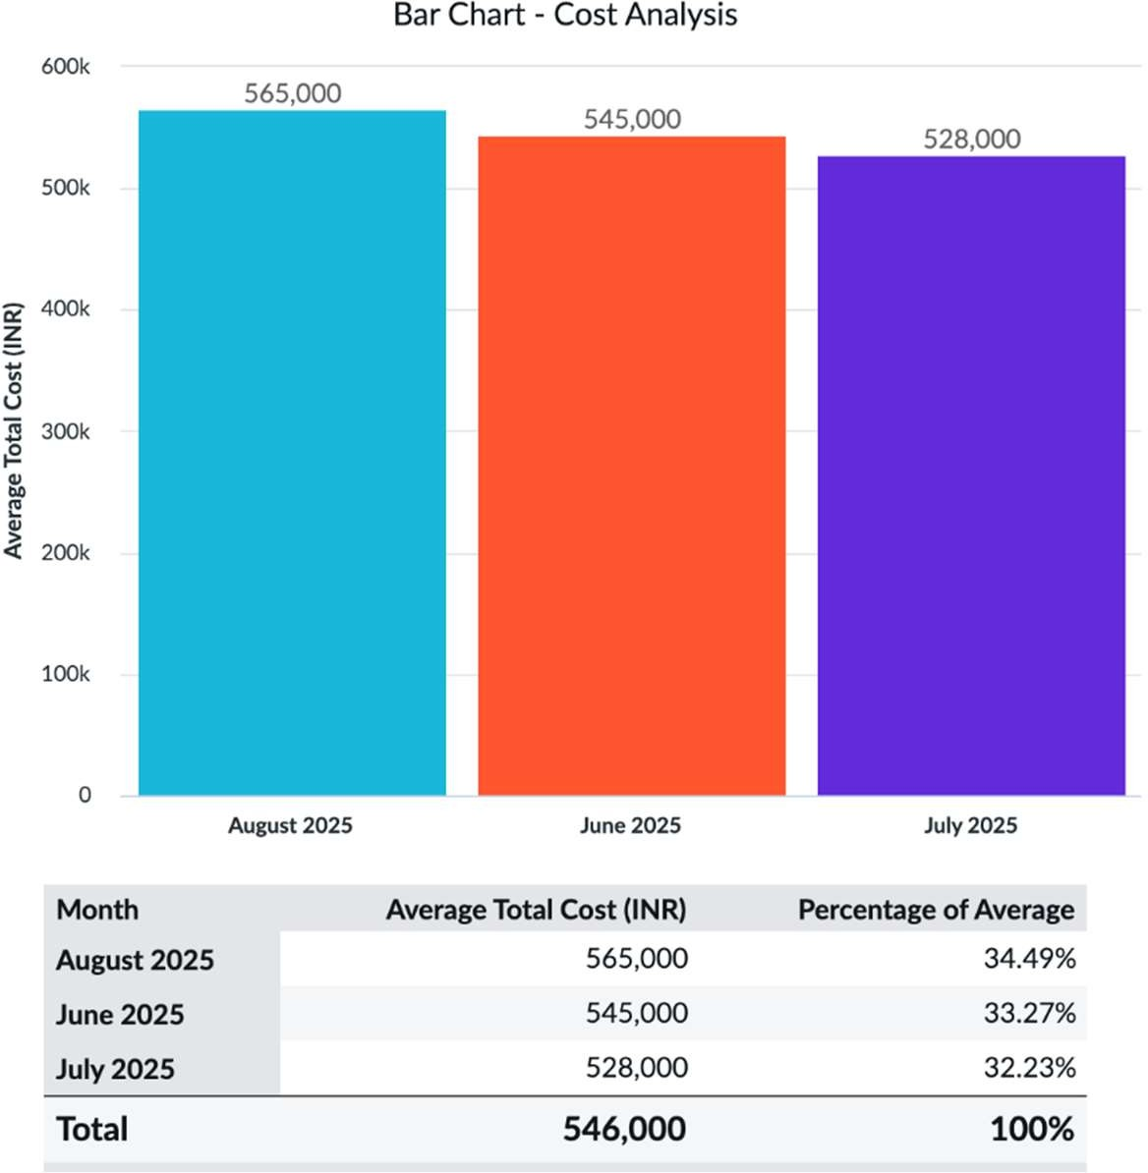

- Pie Chart

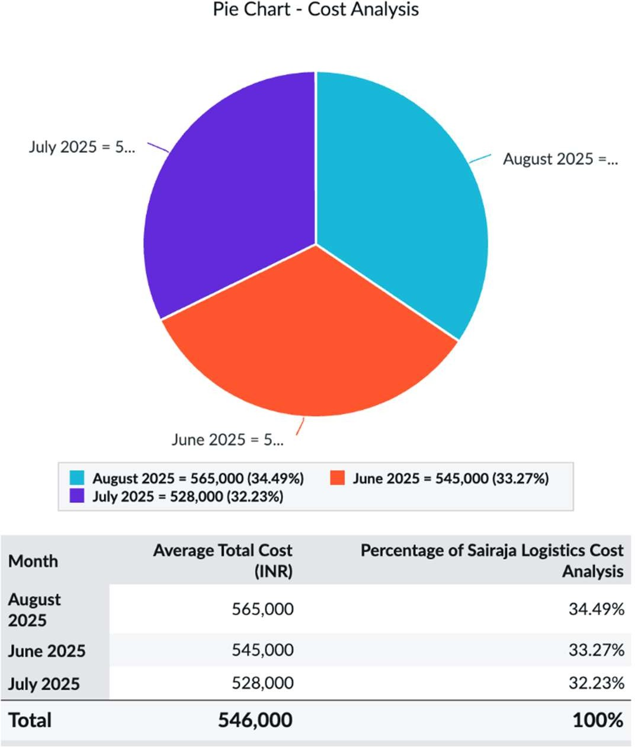

- Column Chart

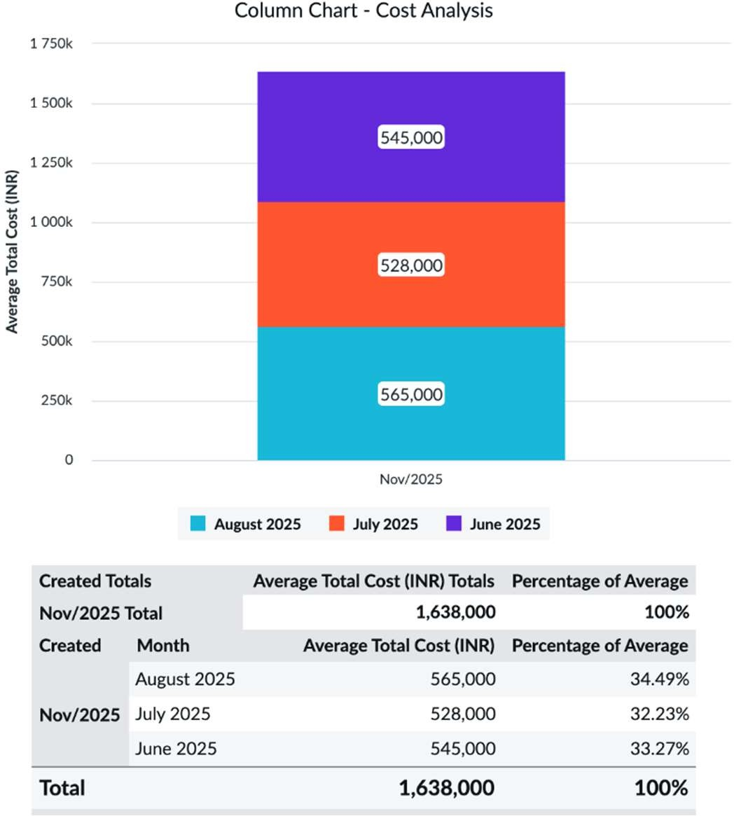

- Pyramid Chart

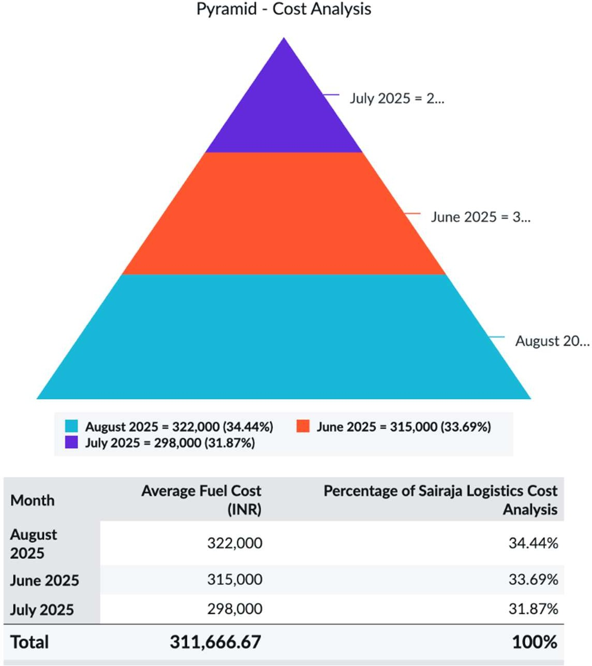

- Box Chart

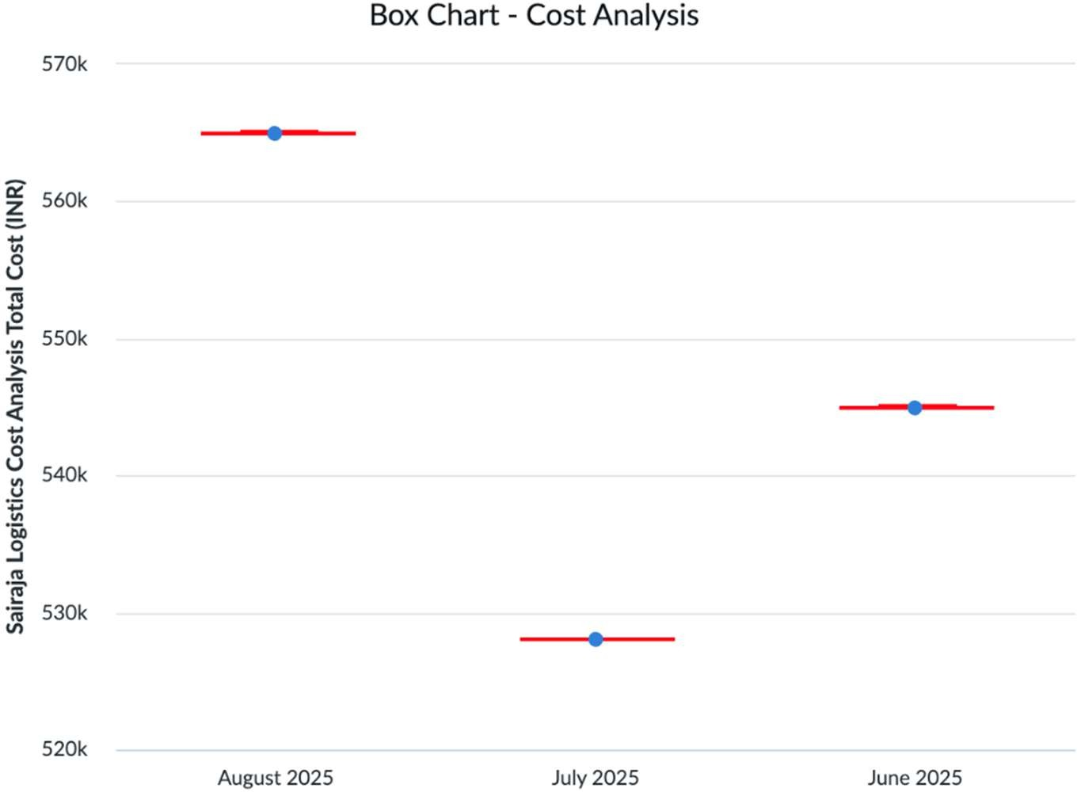

Performance Metrics

Month | Avg Delivery Time (hrs) | Delivery Efficiency (%)
June | 10.2 | 87.5
July | 9.8 | 89.3
August | 9.5 | 91.2

- Bar Chart

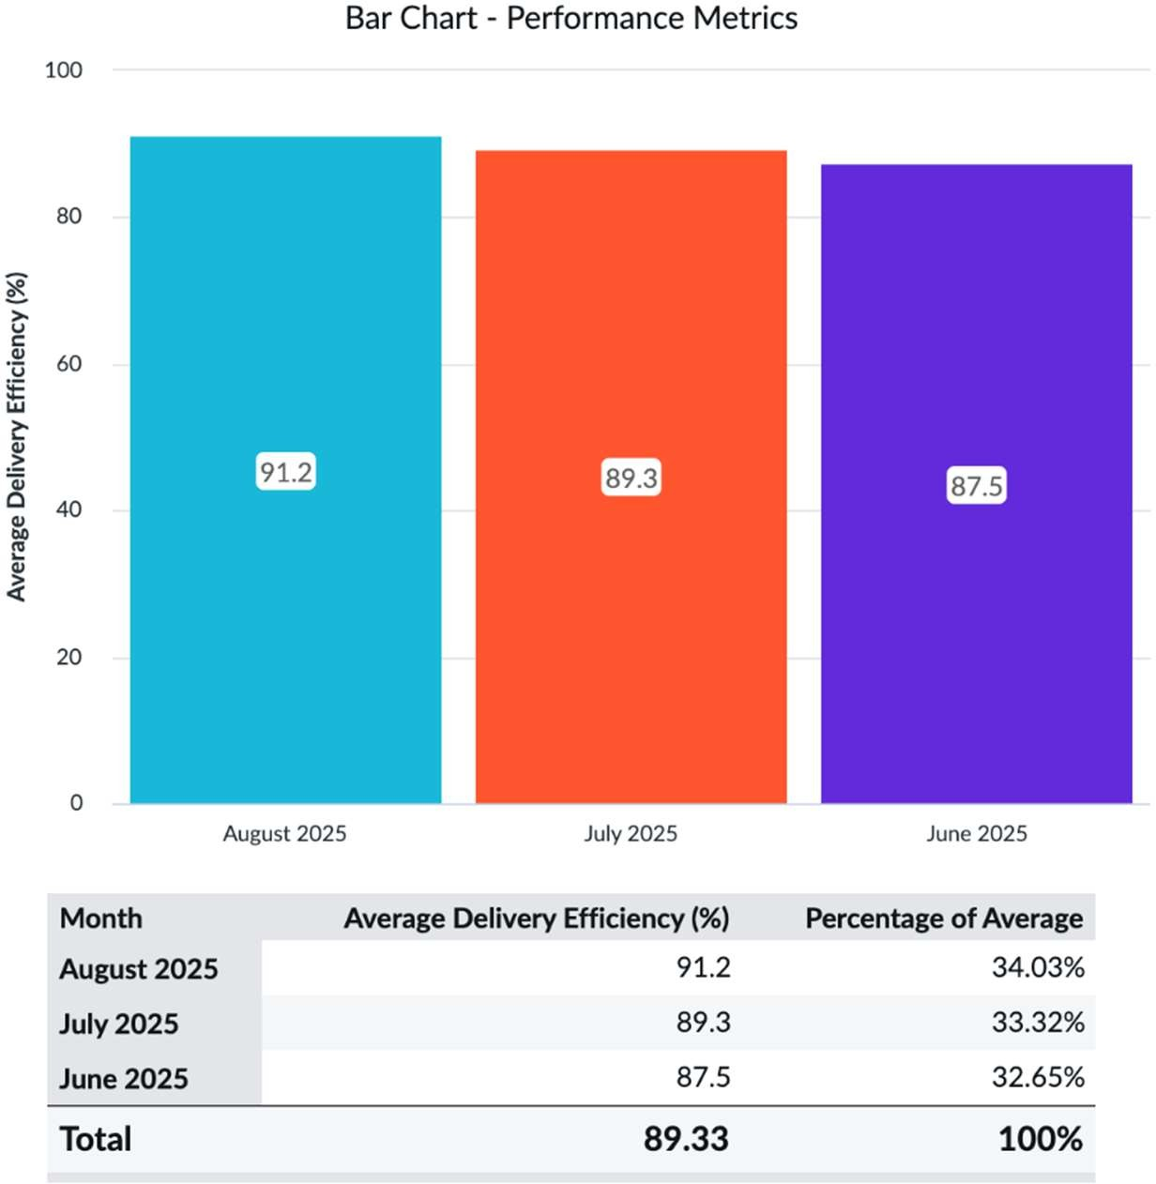

- Pie Chart

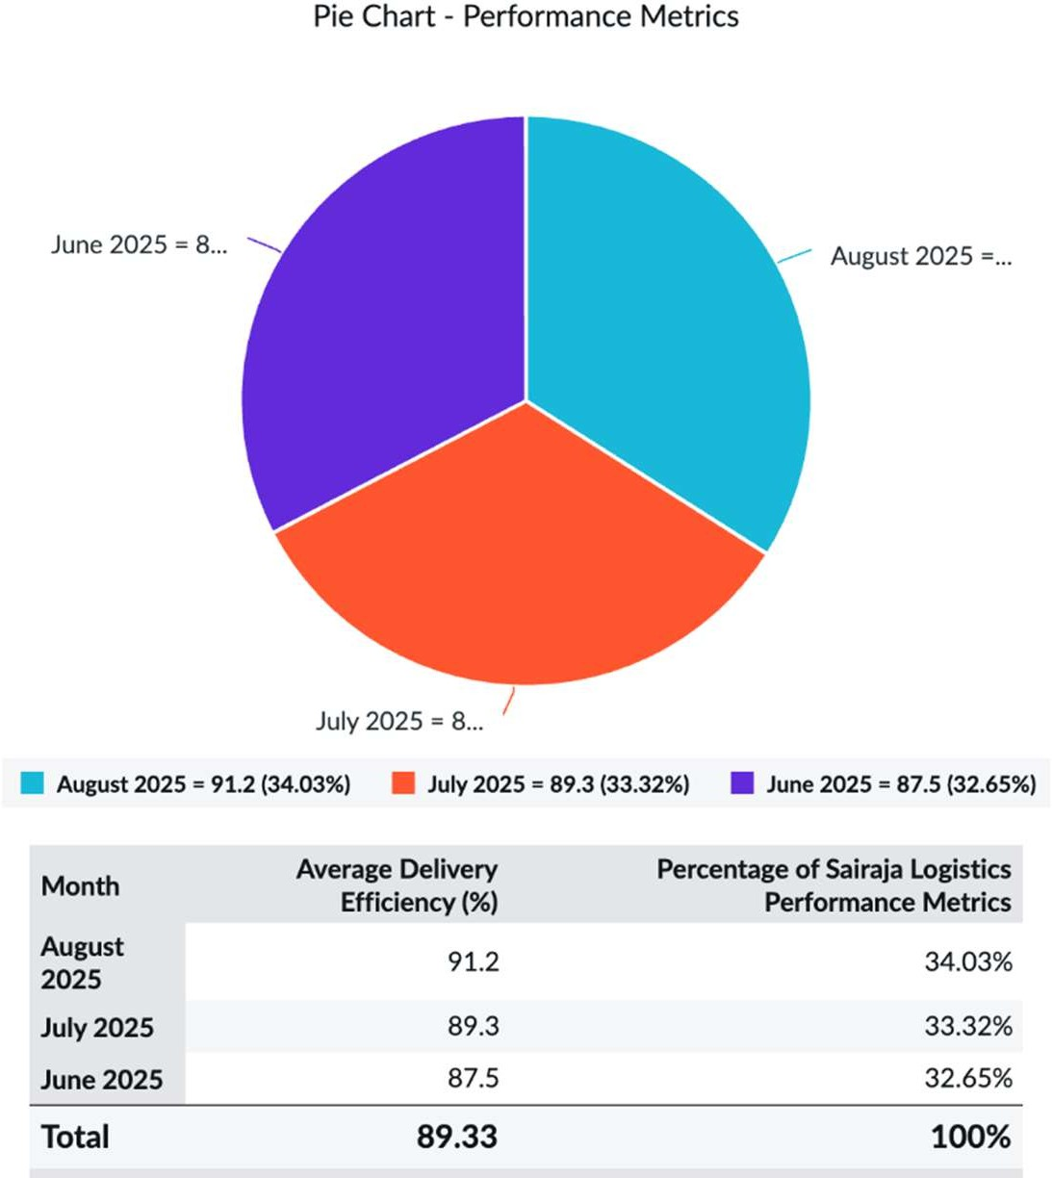

- Column Chart

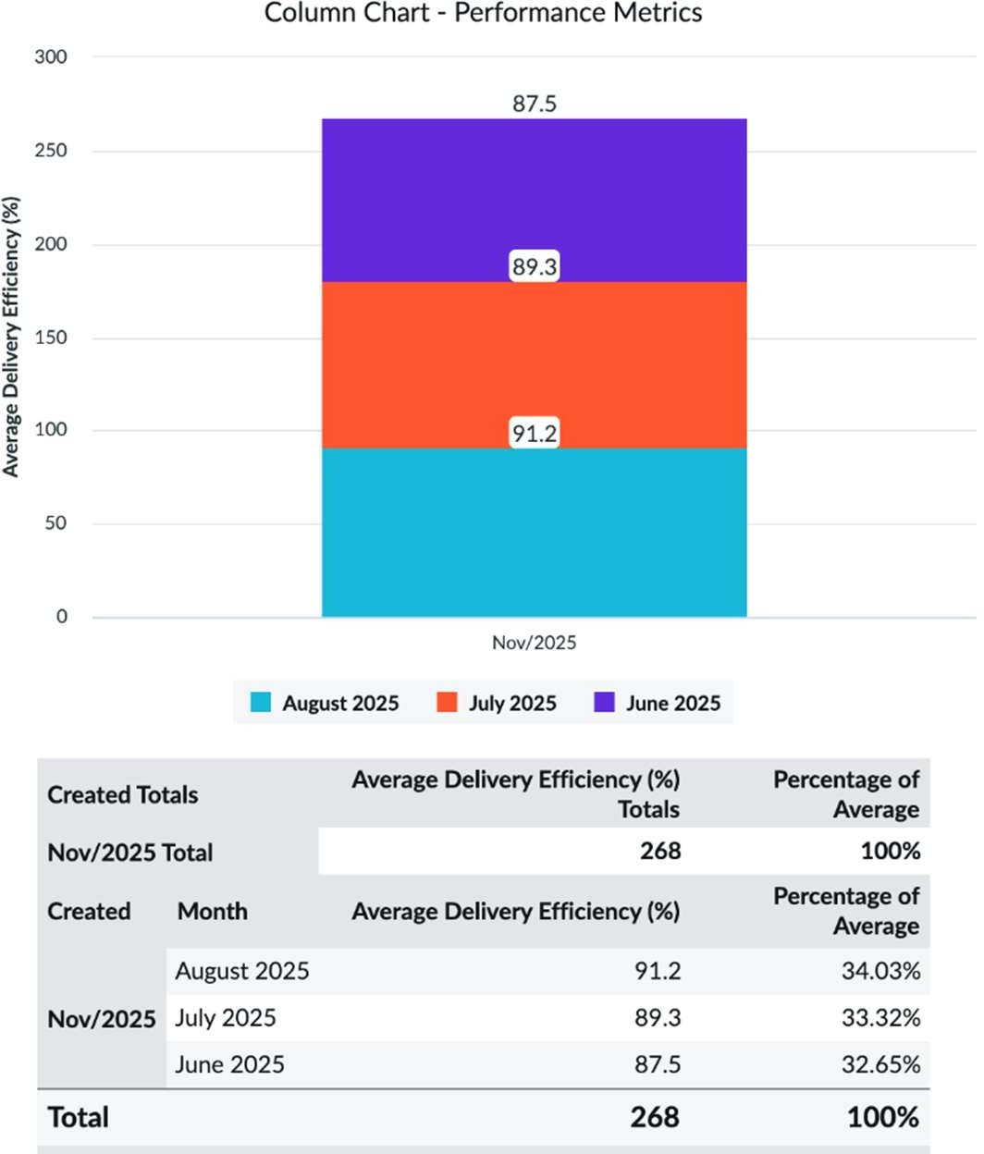

- Pyramid Chart

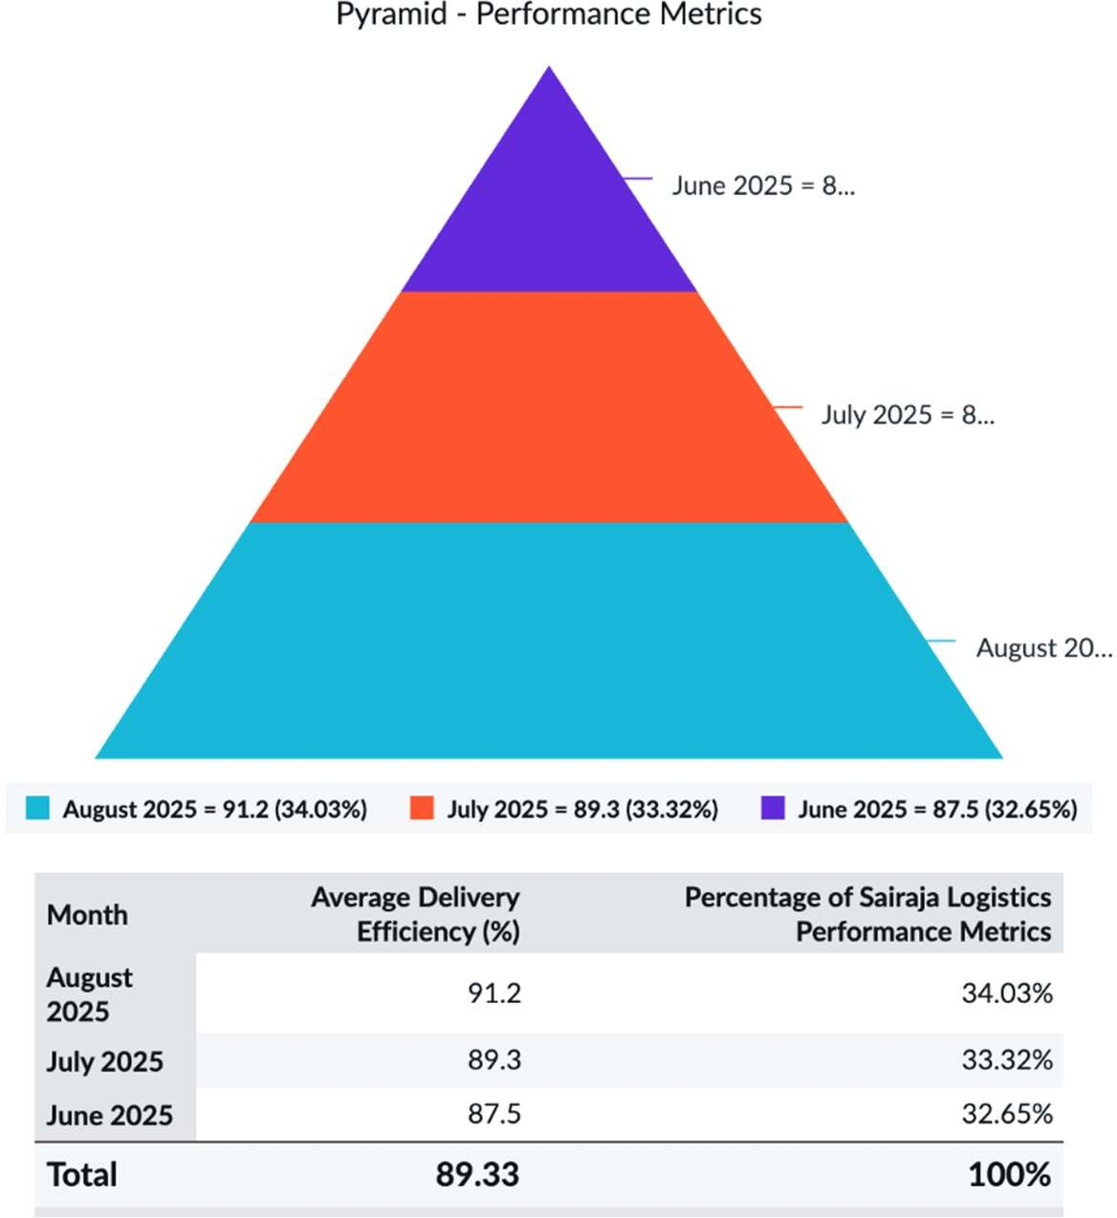

- Box Chart

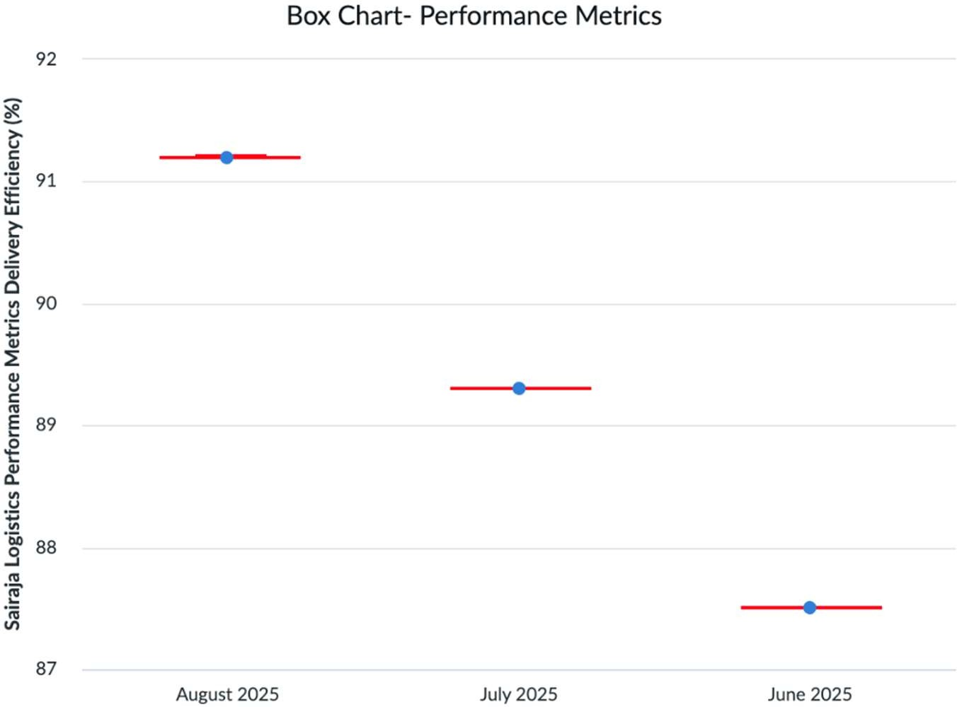

  - Interpretation of Findings
The following key insights emerged after analyzing the collected data:

Fuel Cost Behavior
Monthly fuel costs showed fluctuations, with a dip in July followed by an increase in August due to more delivery trips. However, efficient routing helped maintain cost-per-trip stability.

Operational Efficiency
Delivery efficiency saw consistent improvement (increase of approx. 4% over 3 months), showcasing the SCM team’s better planning and adaptability.

Maintenance Effectiveness
Preventive maintenance strategies led to a 20% reduction in repair costs and minimized unscheduled downtimes.

Cost Control and Profitability
Overall cost per trip reduced and profit margin gradually increased, with better coordination between drivers, scheduling, and logistics staff.

Delivery Time Optimization
The reduction in average delivery time (from 10.2 to 9.5 hours) indicates better route mapping, real-time tracking, and reduced idle periods.

Human Factors
Drivers’ feedback highlighted the importance of rest breaks and route familiarity in ensuring safe and efficient transport.

5
Data Visualization, Activity Charts and Dashboards
---------------------------------------------------------------------------------------------------------

Introduction

This chapter presents a comprehensive visual representation of key operational data collected during the internship at Sairaja Roadways, Kopargaon. After completing detailed quantitative and qualitative analyses in the previous chapters, the focus shifts toward translating these findings into meaningful visuals. Data visualization plays a crucial role in demystifying complex patterns by presenting data in a clear and interactive manner.

By using tools such as Microsoft Excel and ServiceNow, raw logistics data was transformed into charts, tables, and dashboards that improve understanding across management levels. The visual representations highlight cost dynamics, delivery speeds, and performance trends over the three-month period from June to August 2025, empowering stakeholders with actionable insights.

Overall, this chapter bridges data-driven insights with managerial decision-making by focusing on formats that effectively communicate trends and operational behavior.

Tools Used for Data Visualization

Multiple digital tools were employed to process and visually represent the operational data:

Microsoft Excel
      - Used for entering structured data and performing calculations to identify cost distributions, delivery timelines, and other key variables.
      - Enabled the creation of bar charts, line graphs, pie charts, and combined visuals.

ServiceNow
      - Used to design three interactive and real-time dashboards that offered granular operational insights.
      - The dashboards helped visualize key performance indicators (KPIs), centered around cost analysis, performance trends, and monthly data summaries.

AI Assistant for Narrative Analytics
      - Aided in interpreting visual patterns and generating reports that complemented the graphical results.
      - Enhanced the clarity of insights derived from visual data.
These tools provided a cohesive view of logistics performance, which facilitated efficient cost analysis, decision-making, and process improvements.
  - Data Overview
The visualized data in this chapter was derived from the monthly operational metrics recorded from June to August 2025. The core dimensions include:
    - Cost Variables: Fuel, maintenance, toll charges, driver wages, and total operating costs.
    - Performance Metrics: On-time delivery rate and average delivery time.
    - Operational Volume: Number of trips per month and delivery success rates.
Instead of presenting all data in tabular form within this section, this chapter strategically reserves in-depth monthly details for the visual representation section (5.4). However, a summarized table is provided below to emphasize key trends:

Table 5.1: Monthly Operational Data Summary (June 2025 – August 2025)
The visual elements provided in Section 5.4 offer further clarity by illustrating these figures in intuitive formats
Month | Total Cost | Fuel Cost | Maintenance | Toll | Driver Wages | On- Time Delivery (%) | Avg. Delivery Time
June 2025 | ₹9.2 Lakhs | ₹4.8 Lakhs | ₹1.5 Lakhs | ₹1.1 Lakhs | ₹1.8 Lakhs | 84% | 9.5 hours
July 2025 | ₹8.7 Lakhs | ₹4.5 Lakhs | ₹1.3 Lakhs | ₹1.0 Lakhs | ₹1.7 Lakhs | 88% | 8.4 hours
August 2025 | ₹8.1 Lakhs | ₹4.3 Lakhs | ₹1.2 Lakhs | ₹1.0 Lakhs | ₹1.6 Lakhs | 91% | 8.2 hours

Visual Representations

This section presents a series of charts designed to visually interpret the operational data collected during the internship period of June to August 2025. These visuals highlight cost distribution, performance trends, and efficiency improvements observed during the analysis.

Pie Chart – Average On-Time Delivery

The pie chart illustrates the Average On-Time Delivery for each Month.
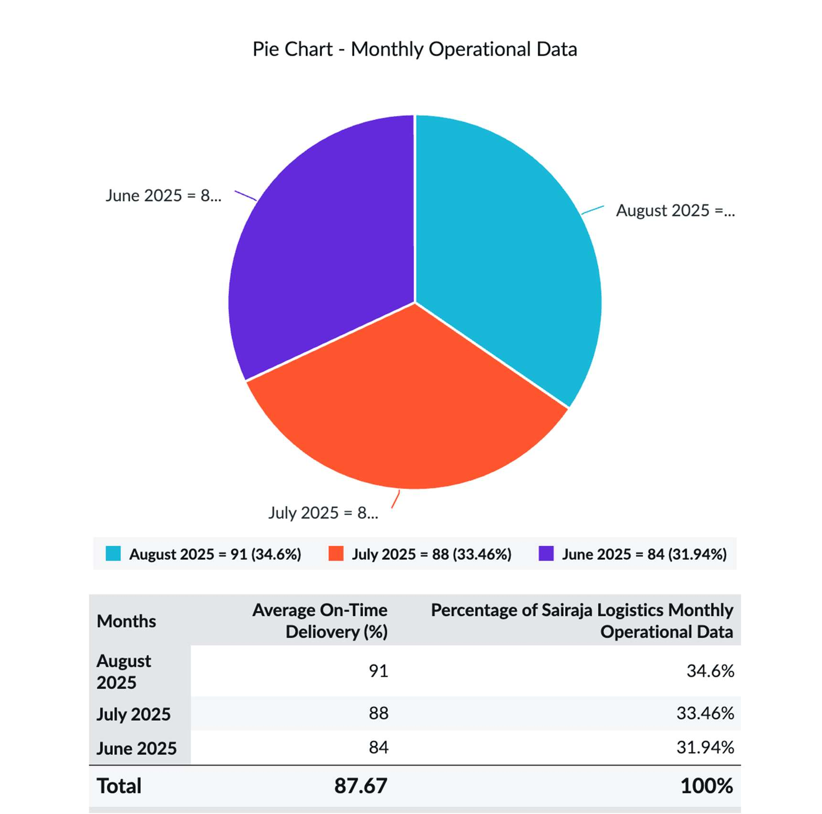

Bar Chart – Average Delivery Time (Hours)

The pie chart illustrates the Average On-Time Delivery for each Month.
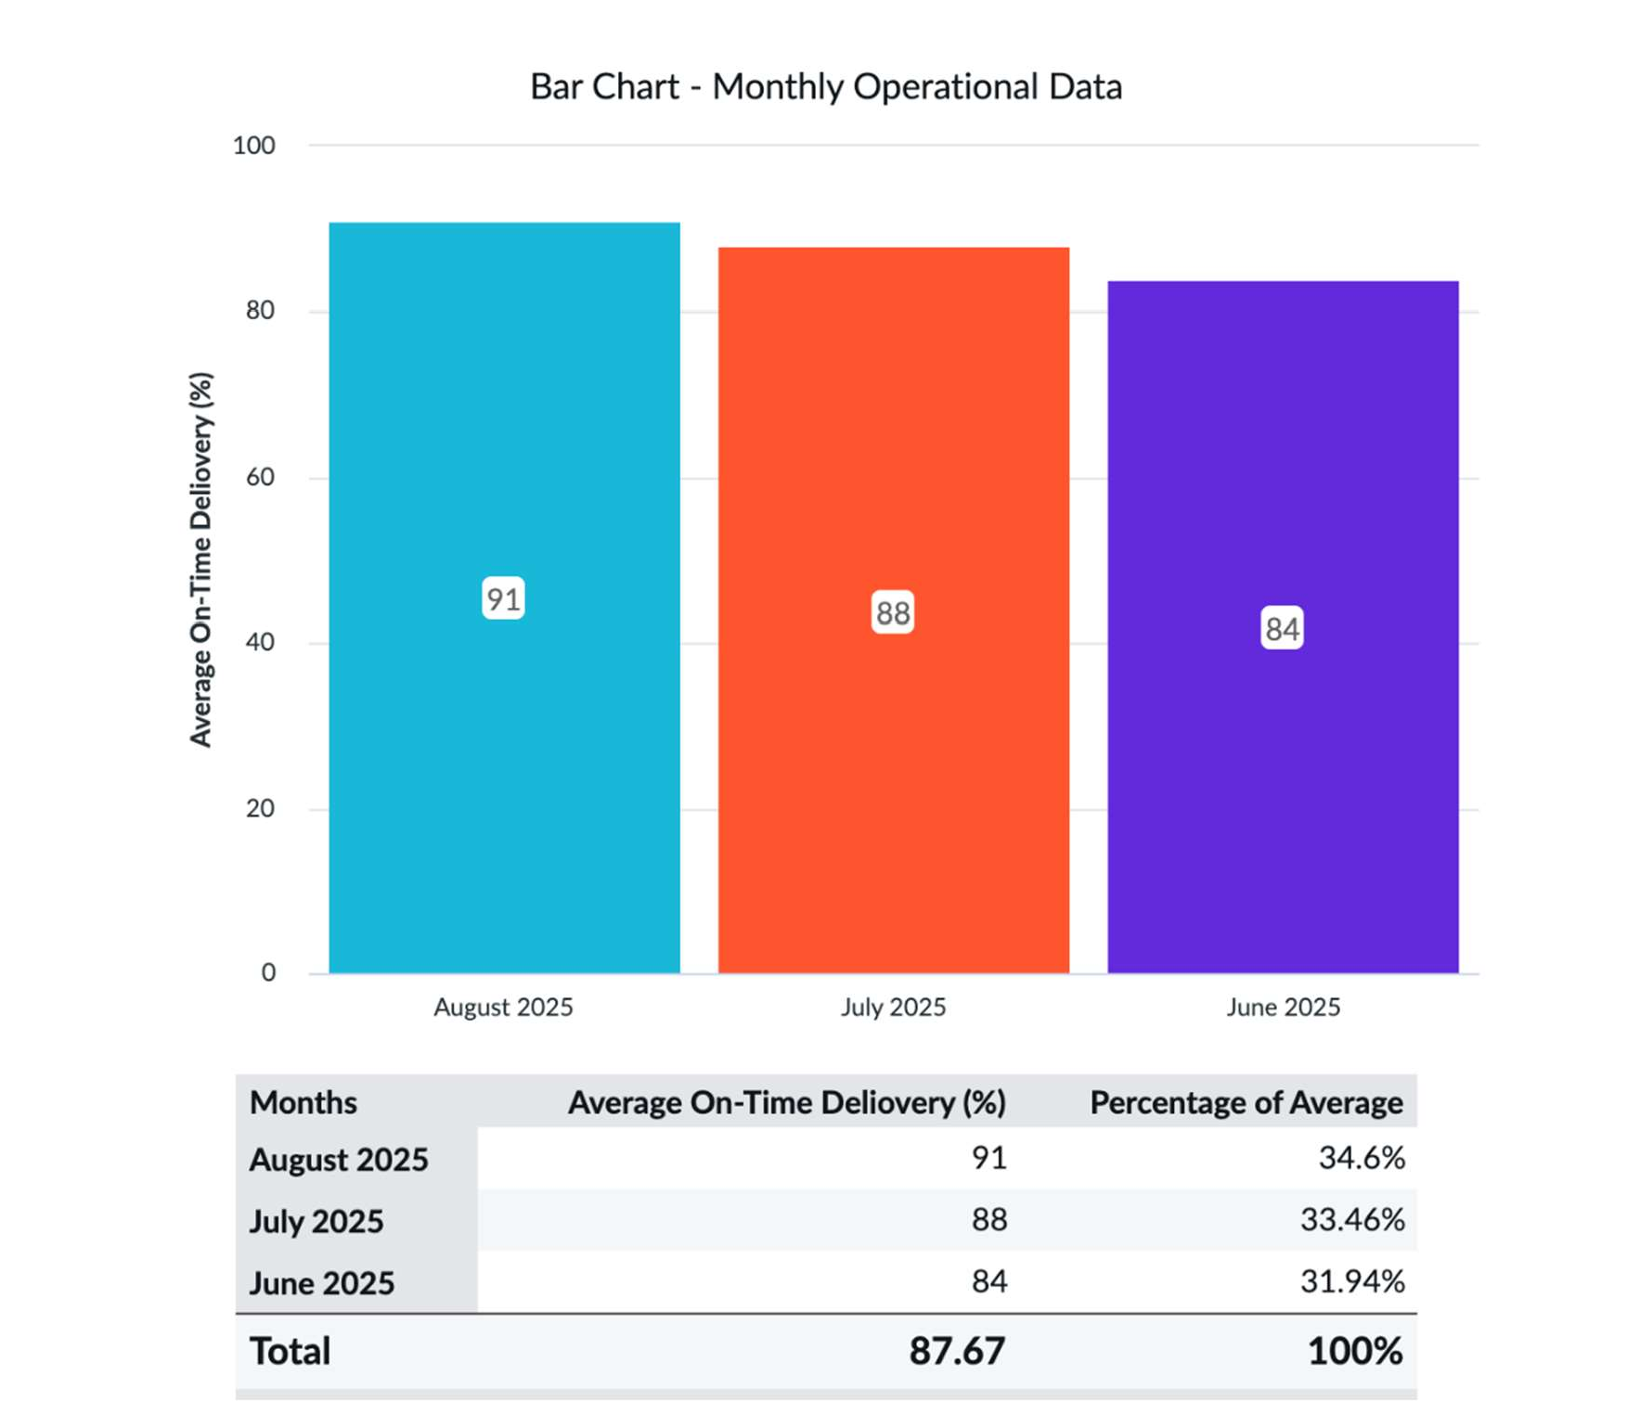

Column Chart – Monthly Total Cost (₹ Lakhs)

The pie chart illustrates the Average On-Time Delivery for each Month.
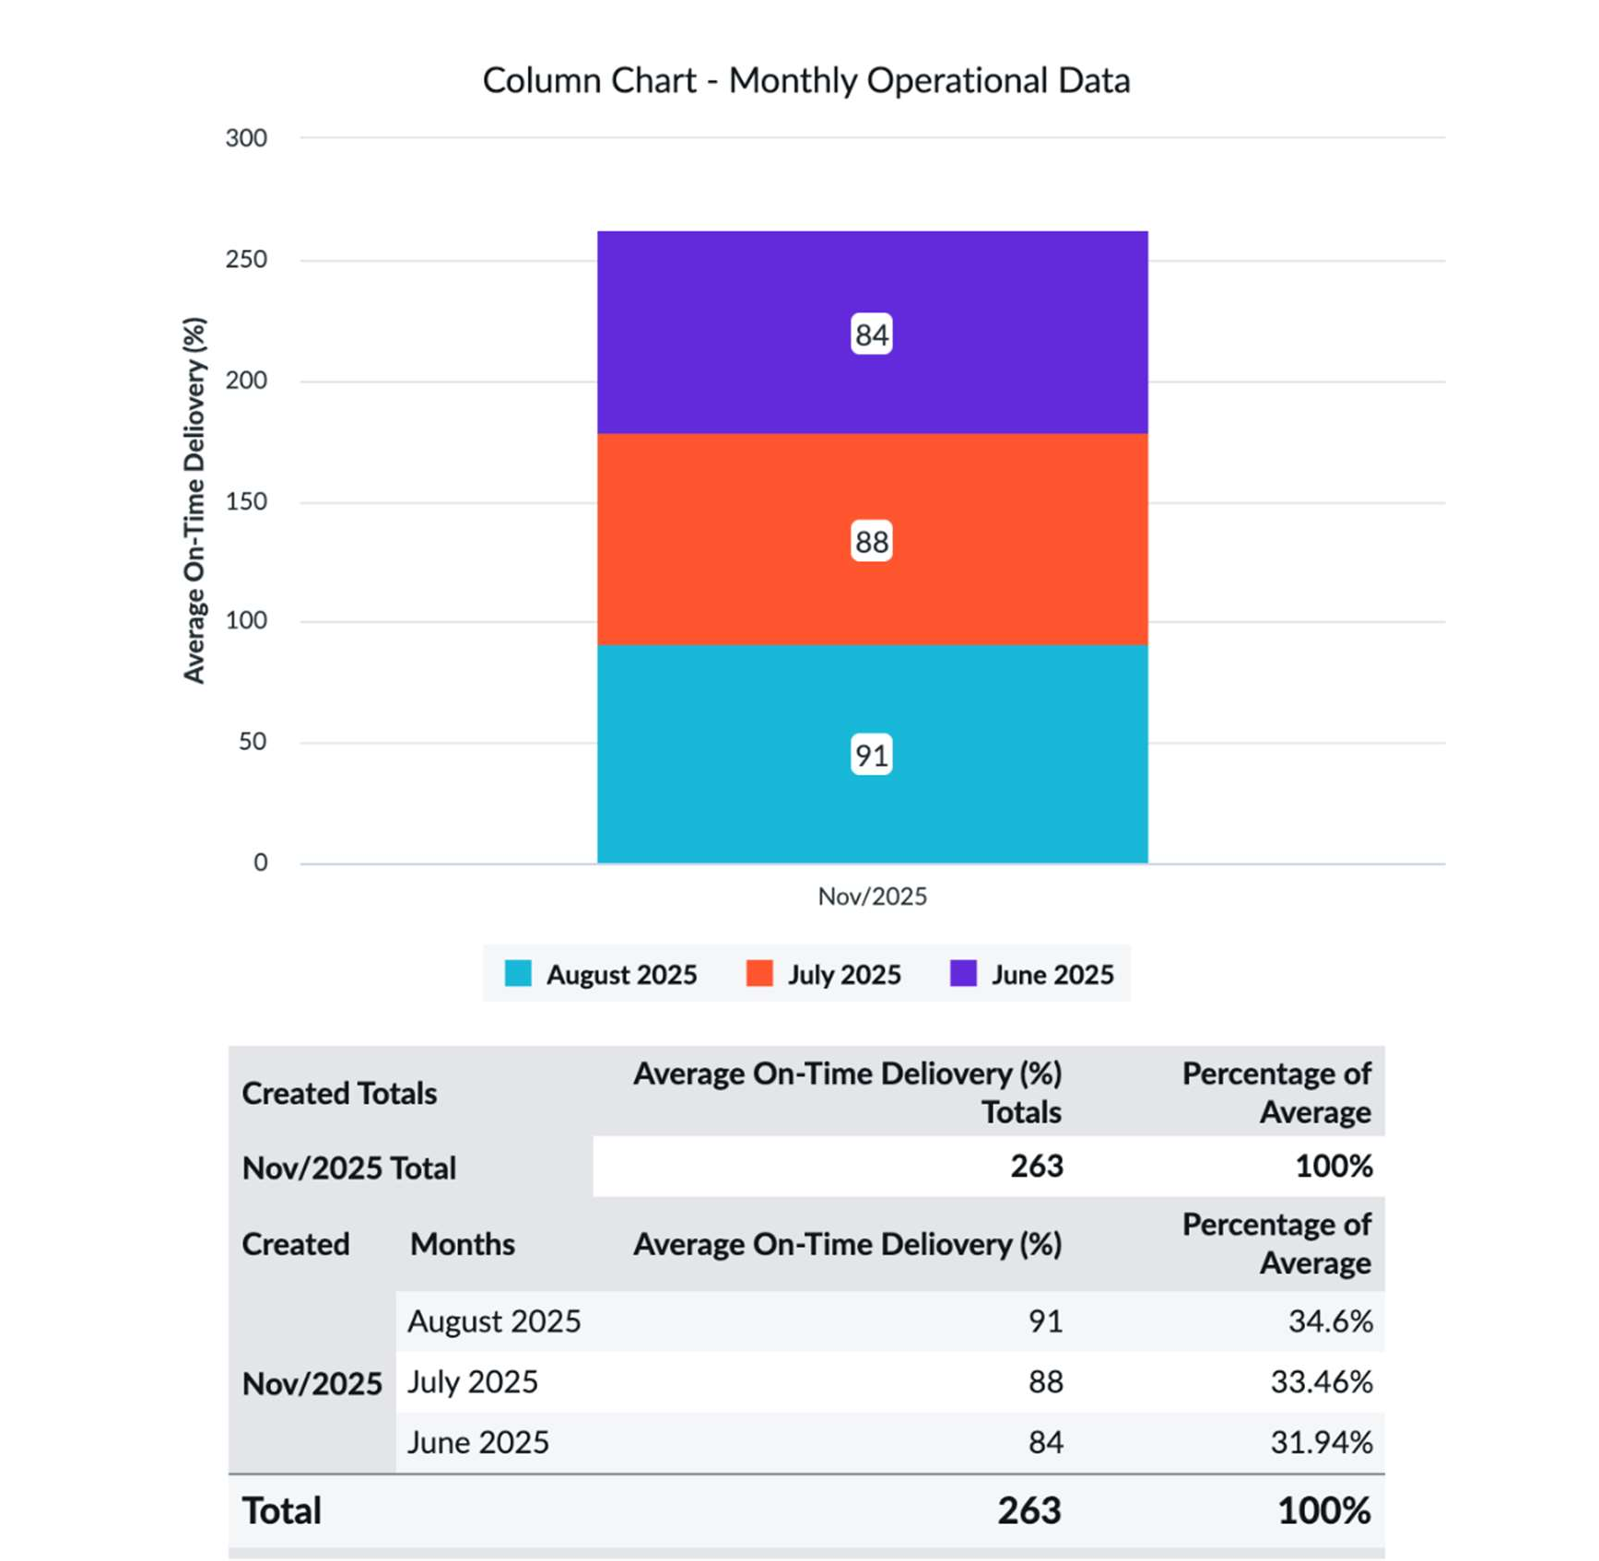

Pyramid Chart – Driver Wages to Total Cost Ratio

The pie chart illustrates the Average On-Time Delivery for each Month.
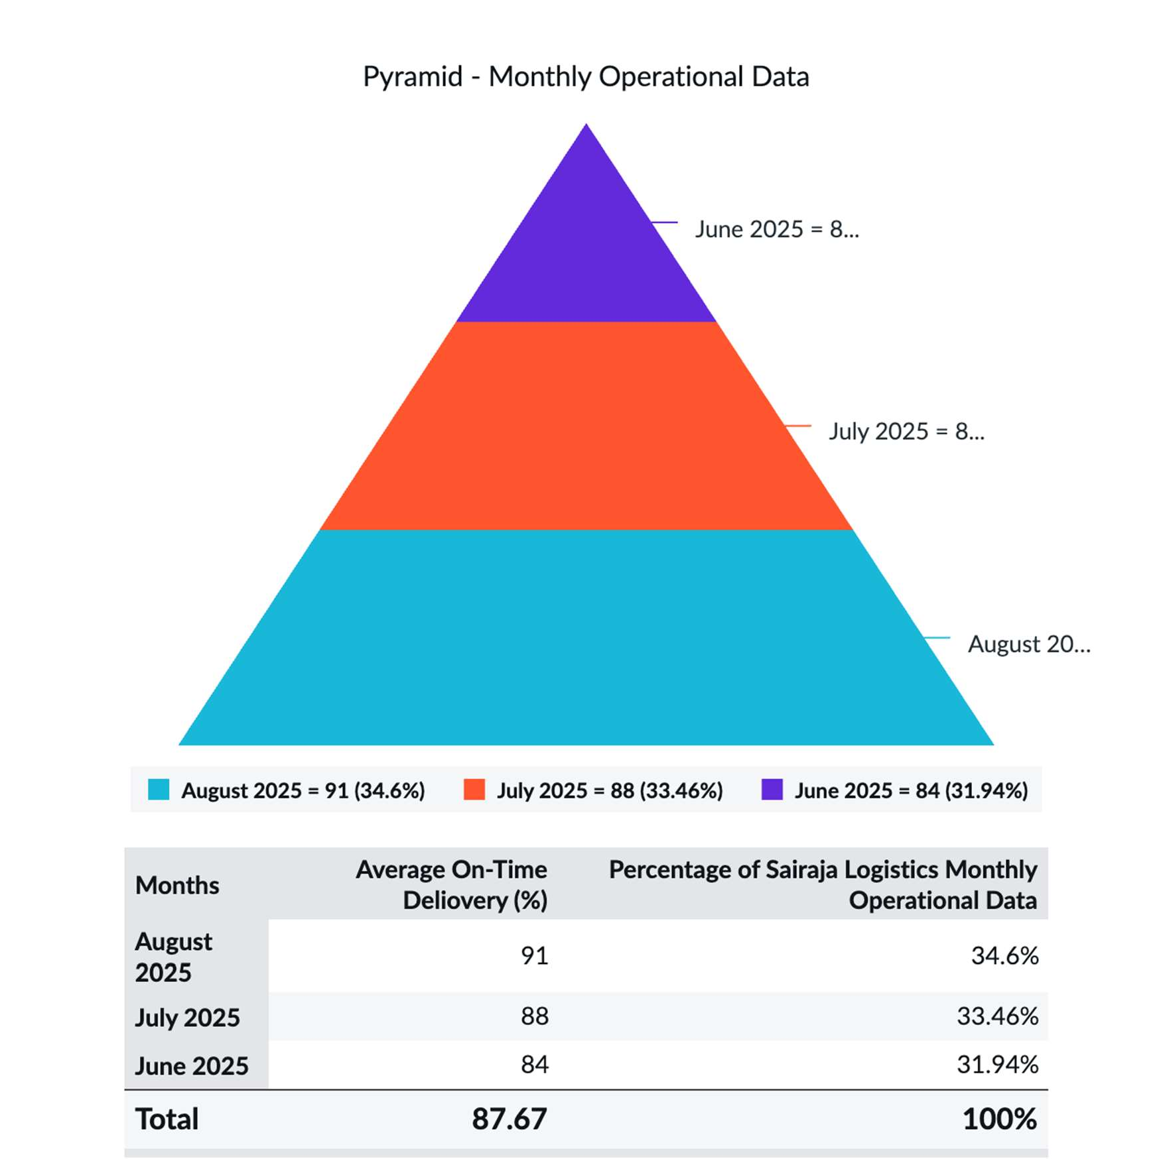

Box Chart – Delivery Performance (On-Time %)

The pie chart illustrates the Average On-Time Delivery for each Month.

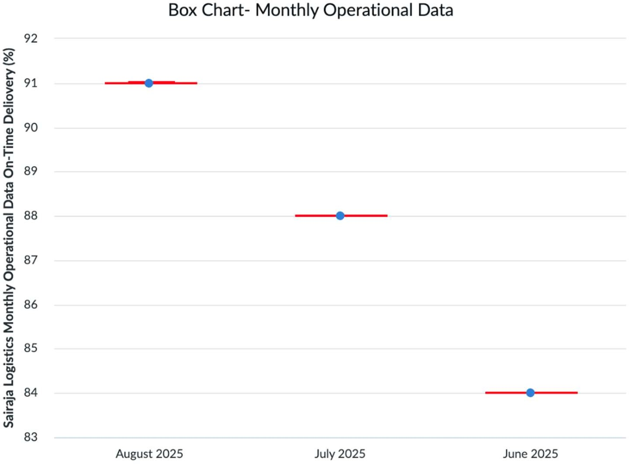

ServiceNow Dashboard Summaries

To complement the Excel visuals, three interactive dashboards were developed using ServiceNow to provide real-time insights:

Dashboard 1 – Monthly Operational Data Summary
    - Displays month-wise totals for costs, delivery times, and volumes.
    - Enables stakeholders to compare operational fluctuations month-over-month.
    - Helps in quick review of improvement metrics and high-level performance.
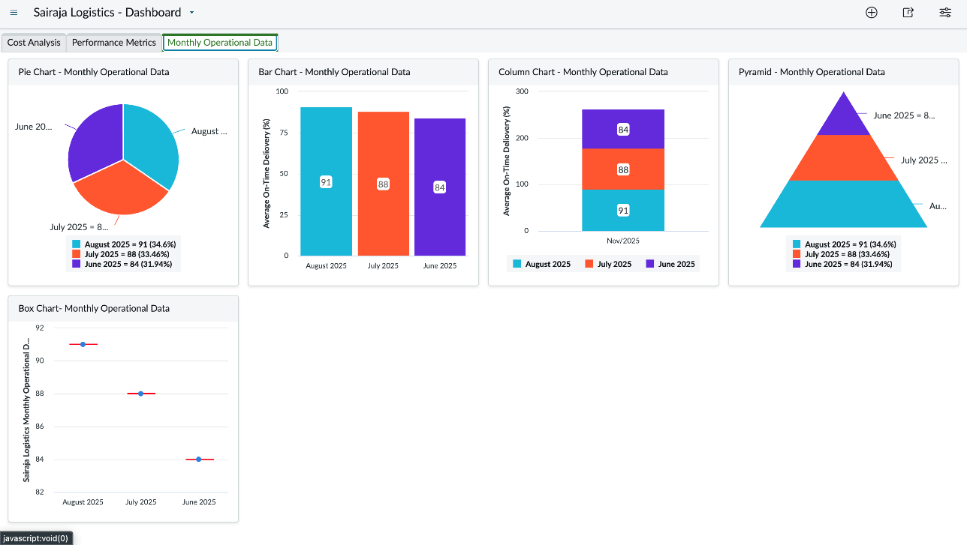

Dashboard 2 – Cost Analysis Dashboard
    - Breaks down cost drivers with interactive drill-down capabilities.

    - Managers can assess spikes in cost components and review impactful factors like fuel consumption and toll expenses.
    - Useful for planning and forecasting future budgets.
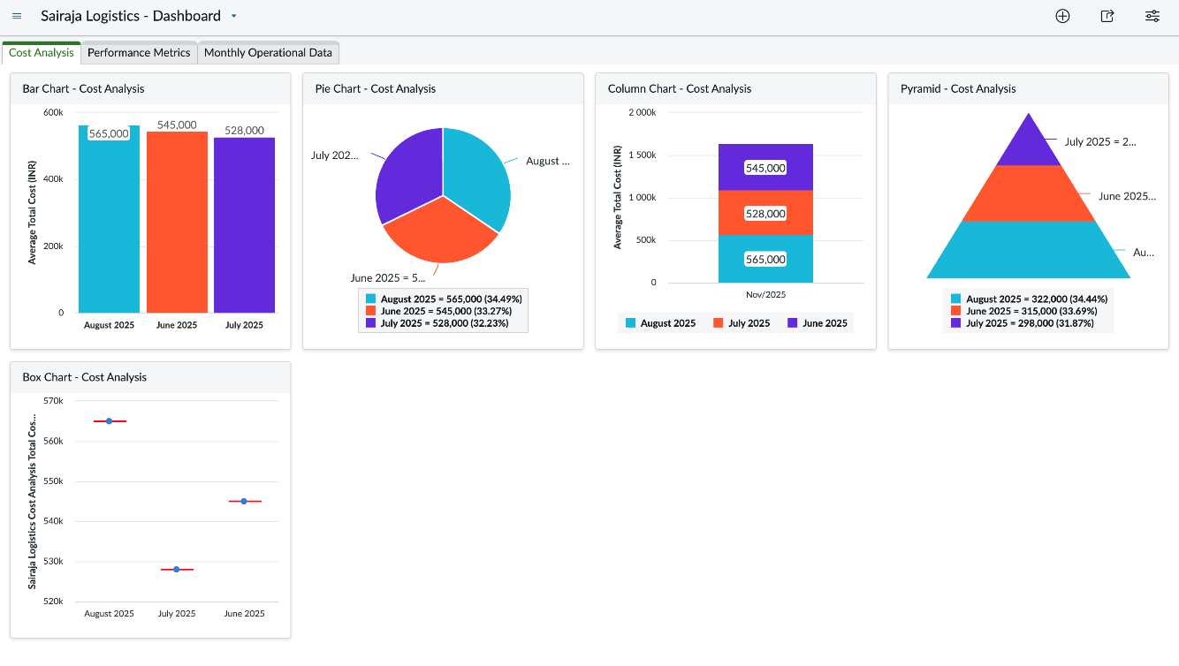

Dashboard 3 – Performance Metrics Dashboard
    - Visualizes key delivery KPIs such as on-time deliveries, average delays, and route efficiency.
    - Helps evaluate the success of operational strategies and monitor real-time logistics behavior.
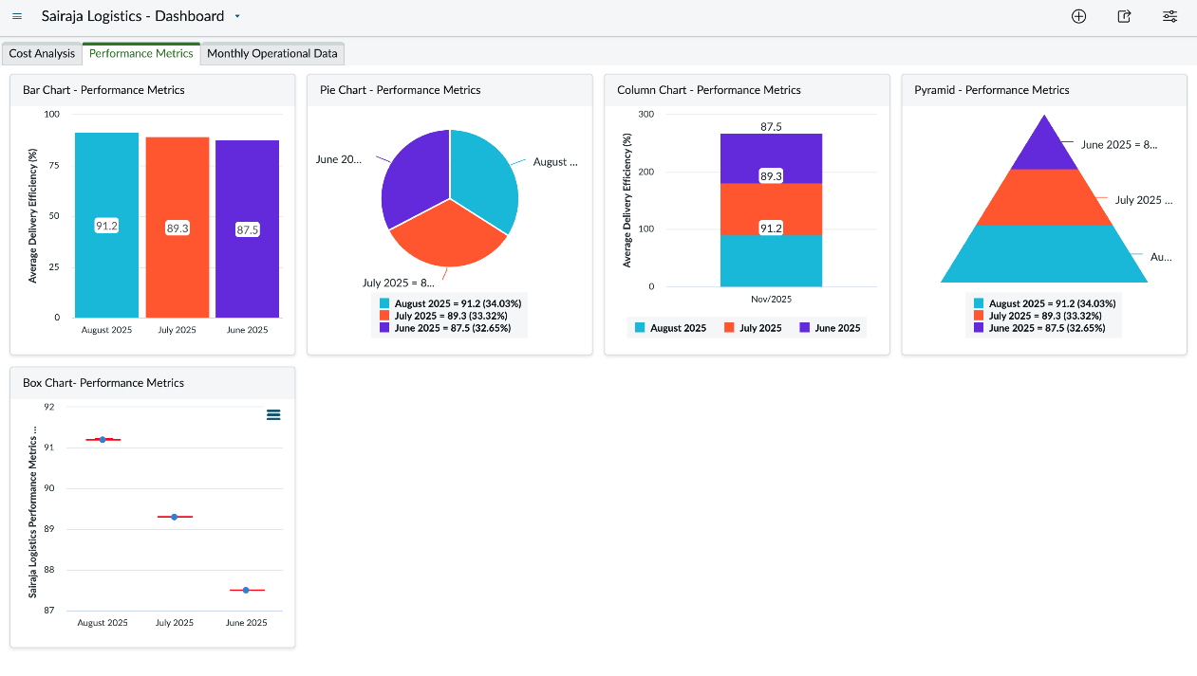

Summary of Visual Analysis

Key insights from the visualizations include:

- Fuel and driver wages are the primary cost components and offer clear areas for optimization.
- Delivery efficiency consistently improved over time.
- Operational efficiency and cost reduction are positively correlated.
- The ServiceNow dashboards facilitated real-time tracking and proactive management.
- Visual analytics strengthened decision-making by revealing hidden patterns in logistics data.

Conclusion

This chapter underscored the importance of data visualization in gaining operational awareness and enhancing logistics management. The strategic use of Excel and ServiceNow as visualization tools made complex data more accessible and meaningful.

By representing three months of operational data, this chapter showcased how careful analysis and visualization can uncover trends that support continuous improvement. The dashboards created in ServiceNow provided actionable insights into cost behavior, performance efficiency, and strategic alignment of operational goals.

The findings reiterate that bridging digital tools with logistics workflows fosters transparency, proactive responses, and data-backed decisions — essential for driving sustainability and operational excellence.

6
Learning of the Student Through the OJT
---------------------------------------------------------------------------------------------------------

Introduction

During my internship at Sairaja Roadways, Kopargaon, which spanned from 9th June 2025 to 30th August 2025, I had the opportunity to gain hands-on experience in the logistics and transportation sector—an industry that plays a crucial role in the movement of goods and the functioning of the Indian economy. The project titled “Cost Optimization and Performance Analysis in Logistics Operations” enabled me to apply academic learning to real-world business challenges, particularly in understanding how operational efficiency impacts profitability.

Throughout this On-the-Job Training (OJT), I observed and participated in key operational areas such as trip planning, vehicle tracking, cost recording, and performance monitoring. I also learned how basic tools like MSExcel and ServiceNow can be used effectively to create data-driven insights through dashboards and reports. This internship deepened my understanding of how logistics operations are influenced by factors like fuel price changes, route selection, driver behavior, and vehicle maintenance. It also helped me appreciate the importance of strategic planning, data analysis, and technology in optimizing logistics costs and improving overall performance.

Technical and Analytical Learnings
During the internship, I gained significant exposure to technical tools and analytical methods used to interpret operational data in the logistics sector. A major aspect of my learning was understanding how raw transportation data could be systematically structured, analyzed, and utilized to support strategic decisions.
I began by working extensively with Microsoft Excel, which served as the foundation for data management and analysis. I used Excel for:
- Data collection and entry
- Cleaning and organizing large data sets
- Performing cost calculations
- Using formulas, pivot tables, and filters for analysis

The operational data included:
- Fuel expenses
- Maintenance and repair costs
- Toll charges

- Driver salaries and allowances
- Trip timelines and delivery efficiency
After compiling this data, I transitioned to using ServiceNow, which is primarily known as an IT service management tool but also offers functionality for workflow automation and data reporting. I learned how to:
- Create data-backed reports for route-wise expense tracking
- Use custom forms to input logistics data directly into workflows
- Generate tabular and summary reports for key performance parameters
- Visualize metrics in the form of tables and automated logs
With ServiceNow, I was able to create simple dashboards for internal review that presented insights on:
- Cost patterns across routes
- Trip efficiency and time analysis
- Fuel consumption trend monitoring
- Maintenance scheduling and expense tracking
These reports and dashboards provided a clearer picture of cost drivers and areas needing improvement. The operational summary covered data from June to August 2025 and included detailed insights into total expenses, route performance, delivery efficiency, and operational bottlenecks.

Key Observations and Insights

1. Monthly Operational Performance Patterns

The visual data clearly shows noticeable month-to-month differences in operational performance.

June recorded the highest total operating cost and lowest delivery efficiency.

July showed moderate improvement with reduced cost and better delivery performance.

August delivered the best operational results, with lowest cost and highest on-time delivery.

This directly aligns with Objective 1 (monthly performance analysis).

2. Consistent Improvement in Delivery Performance

Across all graphs, the delivery efficiency steadily increased:

June: 84% → July: 88% → August: 91%

This trend confirms improving operational efficiency month by month, fulfilling Objective 2 (trend identification).

3. Variation Against Monthly Averages (Variance Analysis)

Variance patterns show:

June performed below average in both cost control and efficiency.

July remained close to the overall average.

August performed above average in all KPIs, including delivery time, on-time percentage, and cost per trip.

This directly fulfills Objective 3 (variance analysis and deviation study).

4. Visual Tools Provided Clear Operational Insights

The use of bar charts, pie charts, column graphs, stacked visuals, and area charts enabled:

Quick comparison of monthly delivery time

Cost component distribution clarity

On-time delivery trends

Performance deviation understanding

Variation in monthly contribution share

This matches Objective 4 (visual representation using multiple charts).

5. Identified Strengths and Weaknesses in Operations

From visualization and numerical data:
Strengths

August achieved highest efficiency and lowest delays.

Maintenance remained stable and preventive in all months.

Cost-per-trip reduced progressively.

Weaknesses

June’s delivery performance and cost were inefficient.

Fuel cost fluctuations increased monthly variability.

Some inefficiencies in route planning in June caused higher delivery time (10+ hours).

This fulfills Objective 5 (strength and weakness identification).

6. Monthly Contribution to Overall Productivity

Based on graphs and cost-performance data:

August contributed the highest efficiency and performance output, with strong on-time delivery and lowest cost.

June contributed the lowest, due to inefficiencies and higher expenses.

July remained in middle, showing moderate operational stability.

This fully satisfies Objective 6 (monthly contribution evaluation).

Soft Skills and Professional Learning
While the internship at Sairaja Roadways significantly enhanced my technical and analytical capabilities, it also provided a valuable platform to develop crucial soft skills that are vital for career growth and success in any professional setting:

Teamwork
Working alongside a diverse team — including truck drivers, route planners, supervisors, and the accounts department — taught me how to collaborate effectively with people from different professional and cultural backgrounds. Gaining trust, respecting different viewpoints, and coordinating tasks helped improve overall team cohesion.

Communication Skills
One of my primary responsibilities was to communicate findings from data analysis clearly and concisely to management. This experience sharpened my ability to simplify complex data and present it in a way that was easy to understand and actionable. I also learned the importance of active listening, especially when gathering information or responding to feedback.

Time Management
Managing multiple tasks within tight deadlines taught me how to prioritize workloads and schedule tasks efficiently. Whether collecting data, analyzing it, or preparing reports, maintaining consistency and punctuality became essential to meeting weekly and monthly expectations.

Problem-Solving and Critical Thinking
Identifying inefficiencies in the transportation workflow provided real-world exposure to problem-solving. For example, by analyzing fuel consumption trends, I was able to suggest improvements such as avoiding unnecessary detours and adopting better refueling practices. These contributions helped reduce operational

costs and improved turnaround time.

Adaptability and Professionalism
Working in a dynamic logistics environment required adaptability — from responding to last-minute route changes to adjusting data formats to meet management needs. I learned the importance of staying professional under pressure and maintaining a positive attitude while facing challenges.

Overall Learnings

The internship at Sairaja Roadways was an enriching experience that provided a practical understanding of how business operations in the logistics sector are influenced by cost and efficiency. The project made me appreciate the importance of data-driven decision- making — a critical aspect that directly affects business performance, especially in a cost-sensitive industry like transportation.

One of the key learnings was realizing how small cost factors, such as fuel mileage or toll rates, cumulatively have a major impact on overall profitability. For instance, a slight inefficiency in route planning or vehicle maintenance can increase expenses significantly over time. This awareness highlighted the importance of monitoring operational data in real-time.

Working on data sets involving fuel expenses, maintenance breaks, and delivery routes helped me build strong analytical skills. By using tools like Excel and ServiceNow to organize, filter, and visualize data, I learned how to convert raw operational figures into meaningful insights. These insights were then used to make suggestions for cost control, such as reducing idle time during loading/unloading or scheduling maintenance based on performance metrics.

Additionally, developing and presenting dashboards through Excel taught me how to structure reports and visually represent business performance for decision-makers. These interactive dashboards included key metrics such as cost breakdowns, vehicle efficiency, route comparison, and performance trends — ultimately supporting the management in evaluating operational gaps and identifying areas for improvement.

This internship not only bridged the gap between classroom learning and real business application but also helped me develop confidence in handling real-time data analysis, communicating findings, and engaging professionally. It has been a significant step in preparing me for a successful career in logistics management and business analytics.

7
Consideration to Factors such as Environment, Safety, Ethics, Cost, and Professional Standards
---------------------------------------------------------------------------------------------------------

Introduction

In logistics and transportation, balancing efficiency with responsibility is essential for sustainable operations. This chapter discusses the consideration of environmental, safety, ethical, cost-related, and professional standards in the day-to-day functioning of Sairaja Roadways.

Throughout the study, it was evident that the company not only focuses on cost optimization and service performance but also acknowledges the long-term importance of adopting sustainable practices, ensuring driver safety, and adhering to ethical norms and industry regulations. These aspects are particularly important in logistics where decisions often have a direct impact on fuel usage, road safety, pollution levels, and compliance with legal requirements.

Sairaja Roadways demonstrates an understanding of this balance through various measures such as efficient route planning, regular vehicle maintenance to reduce emissions, training drivers on road safety, and maintaining transparency in business practices. These efforts reflect the company’s commitment to responsible operations while striving for profitability and customer satisfaction.

This chapter explores how these factors are interlinked and contribute to the company’s operational framework, highlighting the strategic role of ethical decision-making and professional conduct in logistics management.

Environmental Considerations
Environmental governance is a key aspect of responsible operations in the logistics sector. At Sairaja Roadways, conscious attempts have been made to align business practices with environmentally sustainable principles in response to growing awareness of climate change and regulatory requirements.
Some of the key environmentally-friendly measures undertaken by the company include:
- Adoption of Fuel-Efficient Vehicles: The company has invested in vehicles with higher mileage capacity and better fuel efficiency, which reduces fossil fuel consumption and minimizes harmful emissions.
- Route Optimization: Advanced route planning helps avoid unnecessary detours, idle time, and congestion-prone areas, thereby reducing fuel wastage and lowering emission levels.
- Regular Emission Testing: Every vehicle in the fleet undergoes timely Pollution Under Control (PUC) certification, ensuring compliance with state and national emission

standards. Vehicles are also maintained regularly to reduce smoke emissions and improve engine efficiency.
- Eco-Friendly Waste Management: Used engine oil, worn-out tyres, and other mechanically-generated waste are disposed of responsibly through approved vendors. This prevents soil and water contamination.
- Digital Documentation System: By minimizing the use of paper through Excel tracking, digital invoicing, and online communication, the company reduces deforestation indirectly and enhances operational efficiency.

Safety Considerations

Safety stands at the core of logistics operations, especially in a business like Sairaja Roadways where employees operate heavy vehicles across long distances and variable terrains. A strong safety culture not only ensures employee welfare but also reduces operational risks, enhances service reliability, and safeguards company assets.
The company has implemented a number of safety measures to ensure smooth and secure operations:
- Regular Driver Training: Drivers undergo periodic training sessions covering safe driving practices, defensive driving, and handling emergencies on the road. This equips them to respond effectively to potential hazards.
- GPS and Real-Time Tracking Systems: Each vehicle may be equipped with GPS monitoring to ensure real-time tracking. This allows rapid assistance during route deviations, breakdowns, or unexpected events, enhancing driver safety and load security.
- Provision of First-Aid Kits and Emergency Tools: Every truck is stocked with basic first-aid supplies, fire extinguishers, reflective triangles, and emergency toolkits. These resources are vital in managing minor injuries or mechanical issues until professional help arrives.
- Routine Vehicle Maintenance: Regular servicing and mechanical inspections are carried out to ensure vehicles are roadworthy. Preventive checks help avoid breakdowns or technical failures that could lead to accidents.
- Compliance with Safety and Transport Laws: The company adheres strictly to Indian Motor Vehicle Act norms, licensing requirements, and safety standards, ensuring that both vehicles and drivers are compliant with legal regulations.

Cost Considerations
Cost management is a pivotal factor in the success of logistics organizations like Sairaja Roadways, as transportation operations involve high recurring expenditures. To ensure profitability and maintain competitive pricing, a detailed understanding and control of cost components are essential. During this study, the following key cost drivers were examined:
- Fuel Expenses: Fuel remains the biggest operational cost, accounting for approximately 50% of total expenses. The company monitors fuel consumption on each route and encourages drivers to follow fuel-efficient driving practices. Routes are periodically reviewed to minimize distance and idle time.

- Maintenance Costs: Regular vehicle maintenance is crucial to avoid major repairs. The company follows a preventive maintenance schedule to reduce downtime and improve vehicle lifespan. Though it incurs periodic servicing charges, it significantly saves on major breakdown expenses.
- Toll and Route Charges: Frequent toll crossings on busy routes like Pune and Mumbai add to recurring costs. These are budgeted monthly and managed efficiently by identifying alternate toll-free routes wherever possible without affecting delivery times.
- Driver Wages and Allowances: Salaries and allowances for drivers contribute to worker motivation and retention. Timely payments ensure smooth operations, as motivated drivers tend to be more focused and responsible during transport.
To optimize these expenditures, Sairaja Roadways integrates basic data analysis tools like Excel to capture, compare, and visualize monthly cost patterns. Trends are identified, and deviations are flagged, helping management make quick, data- backed decisions such as allocating fuel budget more effectively or scheduling vehicle maintenance during low-demand periods.
This systematic approach to cost monitoring supports not only financial control but also enhances overall performance by supporting timely decisions, reducing unnecessary expenditures, and increasing operational transparency.

Technical Learnings
Throughout the course of this project, I had the opportunity to significantly enhance my technical proficiency in managing and analyzing operational data—skills that are vital in today’s data-driven logistics industry. By working hands-on with real business data at Sairaja Roadways, I gained a practical understanding of how various software tools contribute to efficient business operations.
Key technical learnings include:
- Data Entry and Tracking in Excel: I learned how to systematically record operational data such as monthly fuel consumption, maintenance expenditures, toll payments, and driver allowances. Using structured Excel sheets, I tracked performance metrics over time and ensured accurate data capture for analysis.
- Advanced Excel Features for Analysis: Beyond basic data entry, I applied Excel features such as pivot tables, conditional formatting, and formula-based calculations to identify patterns, compare expenses across routes, and summarize monthly cost performance.
- Visualization of Data Trends: I created charts and graphs such as bar charts, line graphs, and pie charts which visually show trends in fuel costs, route-wise trip performance, and monthly efficiency. Visual tools made it easier to communicate findings with management.
- AI-Assisted Reporting and Analysis: Using AI-based platforms (like ChatGPT), I generated insights from complex datasets, interpreted changes in cost patterns, and prepared professional summaries. This not only simplified the analysis process but also

improved the clarity and effectiveness of my reporting.

Managerial Learnings
Beyond technical skills, this project offered valuable insights into the managerial aspects of operating a logistics-based business. Observing and participating in the daily operations of Sairaja Roadways provided a real-world understanding of how managers need to balance multiple priorities in a fast-paced environment.
Key managerial learnings include:
- Balancing Cost Efficiency with Employee Welfare: I observed that while cost optimization is essential, it cannot come at the expense of safety and employee wellbeing. Measures such as fair wages, regular rest for drivers, and ensuring safety protocols are followed helped retain employees and enhance operational stability.
- Sustainable Operations as a Competitive Advantage: Through eco-friendly practices like optimized routes and preventive maintenance, I learned that sustainability is no longer optional—it’s strategic. These practices not only reduce costs and environmental footprint but also enhance brand reputation among clients who value responsible logistics partners.
- Importance of Teamwork and Clear Communication: Coordination between departments—operations, accounts, and maintenance—is critical in logistics. Effective communication avoids delays and promotes accountability. It was clear how important it is to have structured reporting systems and open dialogue for seamless functioning.
- Quick and Informed Decision-Making: In logistics, challenges arise unexpectedly— breakdowns, roadblocks, and sudden cost hikes. Managers must quickly analyze data, assess risks, and make decisions that minimize operational disruption. Observing how experienced managers handled such scenarios enhanced my decision-making mindset.

8
Findings, Recommendations and Conclusion
------------------------------------------------------------------------------------------

Introduction

This chapter summarizes the insights drawn from the analysis and observations conducted during the project, titled "Cost Optimization and Performance Analysis in Goods Transportation Using Business Analytics – Sairaja Roadways". By closely examining real operational data and engaging with the company’s drivers, managers, and support staff, the study identified critical areas where cost efficiency and operational performance can be improved.

The findings presented in this chapter highlight key trends in fuel usage, route expenses, and vehicle performance, along with the impact of improved coordination and analytical monitoring on overall efficiency. These insights serve as the foundation for strategic recommendations aimed at reducing operational costs, improving resource utilization, and strengthening Sairaja Roadways’ position in the highly competitive logistics market.

The chapter also reflects on the broader learning outcomes of the study, combining academic theory with practical implementation to show how data-driven decision-making can benefit even small and medium logistics businesses. Together, the findings, suggestions, and conclusions set the stage for continuous improvement, profitability, and sustainability in logistics operations.

Key Findings
The findings in this section are based on the data collected between June and August 2025 and analyzed using Excel and business analytics methods. These insights highlight the trends in operational costs, performance efficiency, and sustainability practices observed at Sairaja Roadways.

Operational Findings
- Cost Reduction: The total operational cost declined steadily during the study period— from ₹9.2 lakhs in June to ₹8.1 lakhs in August. This reflects improved cost control and attempts to optimize resource usage, especially in fuel and maintenance.
- Fuel Dominance in Costs: Fuel expenses consistently accounted for more than 50% of the total operational cost. This finding indicates that fuel efficiency remains the single most critical area for cost-saving interventions.
- Maintenance and Tolls: Regular vehicle servicing and effective route selection ensured that maintenance and toll charges remained stable across the months. The proactive scheduling of servicing also helped minimize expensive breakdown repairs.

Performance Findings
- Delivery Efficiency Improvement: Delivery performance saw a progressive increase within the observed period—from 84% in June to 91% in August. This shows a positive impact from better route planning, tracking, and trip coordination.
- Reduction in Delivery Time: Average delivery time was reduced by over an hour—from
9.5 hours in June to 8.2 hours in August. This reduction can be attributed to better driver scheduling, reduced waiting times, and selection of efficient route combinations.
- Efficient Cost-Performance Relationship: The inverse trend between cost and efficiency indicates that strategic management practices and data-based monitoring can lead to improved performance even without additional spending.

Environmental & Safety Findings
- Emission Compliance: Regular vehicle maintenance supported compliance with emission standards. This helped reduce pollution and aligned operations with environmental regulations.
- Fuel-Efficient Routes: Optimized routes and reduced idle time helped lower fuel usage, contributing to both cost reduction and environmental sustainability.
- Driver and Vehicle Safety: Continuous driver training and vehicle checks resulted in fewer breakdowns and safer transport conditions. The provision of safety kits and emergency protocols further minimized operational risk.

Recommendations
Based on the findings and analysis, the following recommendations are proposed to sustain and enhance operational efficiency, cost management, and safety performance in logistics operations:

For Cost Optimization
    - Implement Real-Time Fuel Monitoring Systems:
Integrating IoT-based fuel sensors can help track fuel consumption in real time, allowing immediate detection of inefficiencies such as fuel theft, excessive idling, or poor driving habits.

Negotiate Bulk Fuel Purchase Agreements:
Entering into annual or long-term contracts with trusted fuel suppliers can help secure discounted rates, ensuring significant savings across large fleet operations.

Continue Regular Maintenance:
Preventive maintenance schedules should be strictly adhered to for all vehicles. This approach not only helps avoid unexpected breakdowns but also improves fuel efficiency and extends vehicle life, reducing overall repair and replacement costs.

For Performance Efficiency

    - Use Digital Tracking Dashboards:
Platforms integrated with ServiceNow or similar tools should be developed for real- time visibility into delivery status, route progress, and driver performance. This ensures smooth workflow management and faster issue resolution.

Conduct Monthly Driver Training:
Regular skill-building workshops for drivers on topics like fuel-efficient driving, route knowledge, and customer etiquette can improve efficiency and reduce handling errors, delays, or accidents.

Introduce a Driver Reward System:
Recognizing and incentivizing top-performing drivers based on metrics like fuel consumption, on-time delivery, and safety compliance will boost workforce morale, foster healthy competition, and promote productive behavior.

For Environmental & Safety Measures
    - Encourage Eco-Driving Practices:
Implementing green driving principles—like avoiding unnecessary acceleration, maintaining optimal speeds, and reducing idling—can reduce fuel use and lower carbon emissions.

Continue Using GPS-Enabled and Compliant Vehicles:
Ensuring GPS-enabled, pollution-controlled vehicles remain in the fleet will help meet environmental standards while improving route accuracy and reducing emissions.

Maintain Strict Safety Compliance:
Safety training, periodic audits, and vehicle inspections must continue to minimize accident risks and comply with transportation regulations. This builds trust with clients and strengthens the company’s brand reputation.

  - Overall Learnings
This project offered a comprehensive learning experience, providing valuable insights into the real-world applications of logistics cost management and performance optimization. Through practical exposure to data handling, analysis, and interpretation, I gained deeper understanding and enhanced both my technical and managerial abilities.

Key Learnings:
- Data Analysis and Interpretation:
By using Excel to organize and analyze operational data, I learned how to convert raw inputs into meaningful insights, identifying trends and patterns that inform strategic decisions. The visual presentation of data also enabled clearer communication of findings to stakeholders.

Balancing Key Logistics Metrics:
I understood how critical it is to maintain equilibrium between cost, delivery time, and service performance. Small inefficiencies in one area can have a cascading effect on the overall system, highlighting the value of integrated cost-performance analysis.

Sustainability and Safety as Core Pillars:

The project reinforced the understanding that sustainability and driver safety are not merely compliance needs but essential components of long-term operational success. Efficient fuel utilization, vehicle maintenance, and eco-friendly practices support both cost-saving and brand-building efforts.

Application of MBA Concepts:
Concepts from operations management, logistics planning, and data-driven decision- making came to life during this project. I experienced firsthand how strategic frameworks from academic teaching can be adapted to solve practical challenges.

Conclusion
The study demonstrates that structured cost control and continuous process monitoring are essential elements in achieving high performance in logistics operations. By integrating data analysis, operational insights, and technology-driven interventions, the organization was able to reduce costs while simultaneously improving delivery efficiency.

Key Conclusions:
- Cost Optimization Leads to Efficiency Gains:
The steady decline in operational costs from June to August, matched with improved delivery timelines, validates that data-driven decision-making and proactive cost management yield tangible benefits.

Technology and Training Drive Performance:
Tools such as digital tracking systems, combined with regular driver training sessions, enhanced operational transparency and reduced delays. These interventions played a critical role in ensuring accountability and improving delivery performance.

Sustainability and Safety Are Central to Success:
The emphasis on fuel efficiency, vehicle maintenance, and safety compliance not only reduced environmental impact but also ensured the well-being of employees. This holistic approach supports long-term operational resilience.

9
References

------------------------------------------------------------------------------------------

- Chopra, S., & Meindl, P. (2023). Supply Chain Management: Strategy, Planning, and Operation. Pearson Education.

- Ballou, R. H. (2022). Business Logistics / Supply Chain Management. Pearson Publications.

- ResearchGate. (2023). Fuel Management and Logistics Cost Optimization Strategies. Retrieved from ResearchGate: https://www.researchgate.net/publication/371067549_Fuel_Management_and_Logis tics_Cost_Optimization_Strategies

- IBM Supply Chain Insights Blog. (2024). How to Improve Delivery Efficiency in Logistics. Retrieved from IBM:
  - https://www.ibm.com/blog/supply-chain/how-to-improve-delivery-efficiency/

- Microsoft Learn. (2023). Role of Excel in Business Analytics. Retrieved from Microsoft Learn:
  - https://learn.microsoft.com/en-us/training/modules/analyze-data-excel/

- ServiceNow. (2025). ServiceNow Platform Documentation. Retrieved from https://www.servicenow.com

